Topic VII

Climate
and
Moisture

Topic: Climate and Moisture
Aim:
Weather: the day-to day changes in atmospheric conditions

How is climate
different than
weather?

Climate: the average monthly temperatures, the temperature range, and
amount of precipitation of a region

1. LATITUDE: different latitudes receive different angles of insolation which greatly influences temperature
a. As latitude increases (approaching poles), the average temperature decreases.

b.

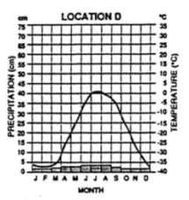
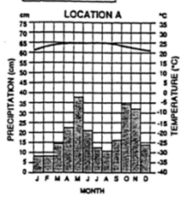
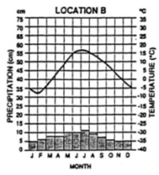
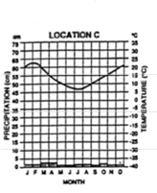
Mid-Latitude
Equator (0º latitude) Northern Hemisphere North Polar Region (90ºN)
(New York)
Mid-Latitude
Equator (0º latitude) Northern Hemisphere North Polar Region (90ºN)
(New York)
Southern Hemisphere
(probably 30ºS)
high average monthly temperatures
always warm (small temperature range)
lots of precipitation (Equator is a wet belt)

Graph shows opposite seasons
of Northern Hemisphere
higher temperatures during our winter months and lower temperatures during our summer months
probably at 30ºS because of the little precipitation shown (30ºS is a dry belt)
average temperature range
average precipitation
low average monthly temperatures
large temperature range
little precipitation
(North Pole is a dry zone)

2. ELEVATION: As elevation increases, the average temperature decreases.

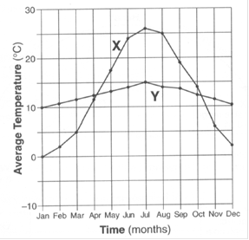
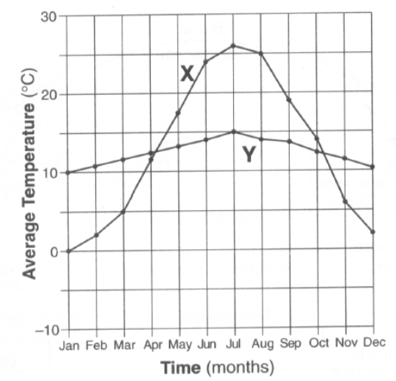
3. NEARNESS TO A LARGE BODY OF WATER:

- Coastal Locations –

- Inland Locations –

Monsoons – seasonal shift in the winds and precipitation – especially experienced in places like India

Monsoons – seasonal shift in the winds and precipitation – especially experienced in places like India

summer

winds blow in from the water which causes a very rainy season
winter

winds shift and prevent moisture from coming inland which causes a very dry season

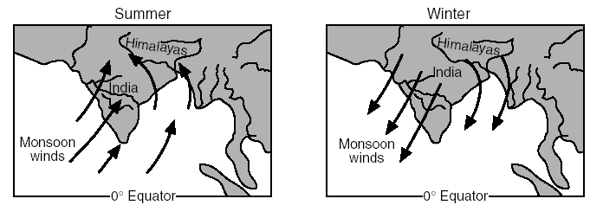

4. MOUNTAINS BARRIERS:

windward side of leeward side of
mountain chain mountain chain
Climate on Windward Side:Climate on Leeward Side:

5. PLANETARY WIND and MOISTURE BELTS (ESRT page 14):

High Pressure Belts - 30o^{N} & 30o^{S}, the poles - dry zones of diverging winds (location of many of the world’s deserts)

Low Pressure Belts - 60o^{N} & 60o^{S}, the Equator - wet zones of converging winds (location of rainforests)

6. SURFACE OCEAN CURRENTS (ESRT page 4):

Ocean currents are “rivers” of water whose motion is driven by the planetary winds.
Specific ocean currents bring warmer or cooler water to coastal locations modifying the climate
(example: the Gulf Stream brings warm water from the Gulf of Mexico to western Europe)

El Niño

a re-occurring ocean current (approx. every 5 years)
that shifts the trade winds and precipitation patterns in the Pacific Ocean

During an El Niño event, the west coasts of North and South America have more precipitation,
and SE Asia and Australia experience drought-like conditions.

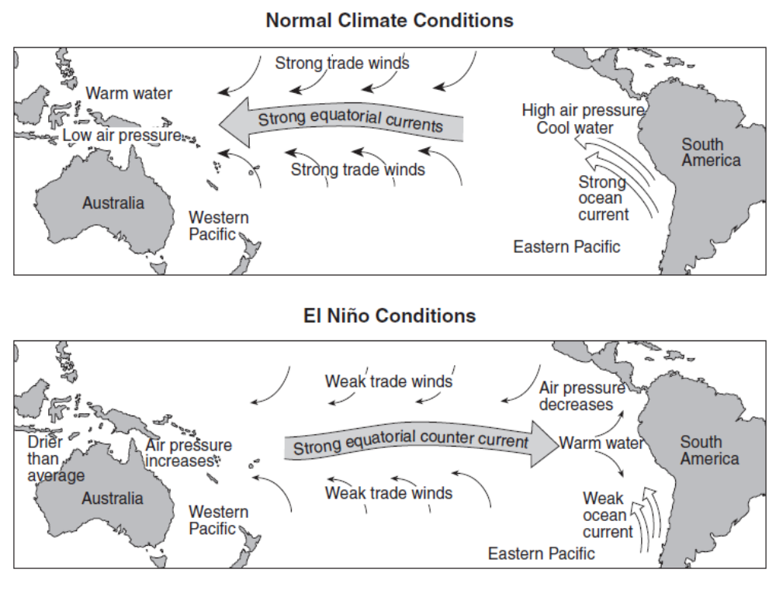

Factors Affecting Climate Review

1. Which two variables are the best to use when describing climate of a region?
(1) temperature and precipitation (3) wind speed and humidity
(2) wind direction and temperature (4) air pressure and elevation

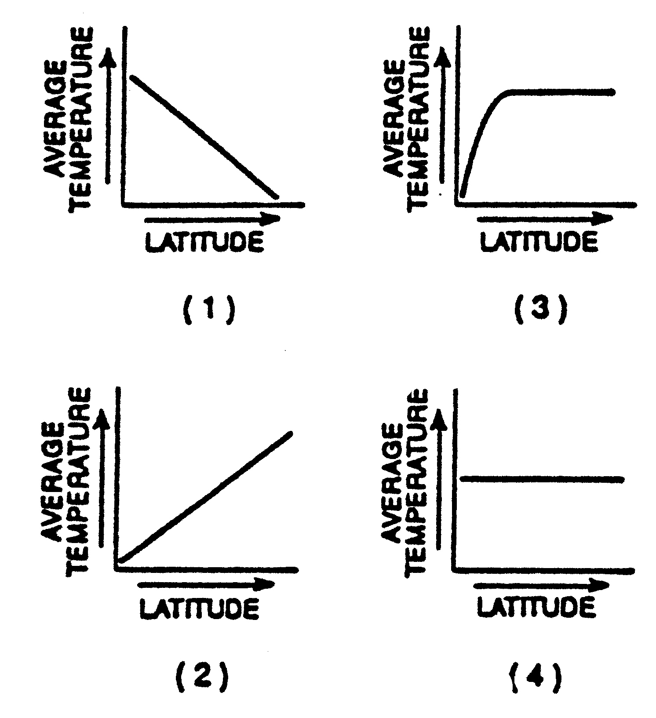
2. Which graph to the right best represents
the relationship between latitude and
average temperature on the Earth?

3. As the elevation above sea level increases, average yearly temperatures will
(1) increase (2) decrease (3) remain the same

4. Compared to a coastal location of the same elevation and latitude, an inland location is likely to have
(1) warmer summers and cooler winters (3) warmer summers and warmer winters
(2) cooler summers and warmer winters (4) cooler summers and cooler winters

5. The Peru Ocean Current is a
- warm current that affects North America.
- cold current that affects the west coast of South America.
- warm current that affects west coast of South America.
- cold current that affects the east coast of South America.

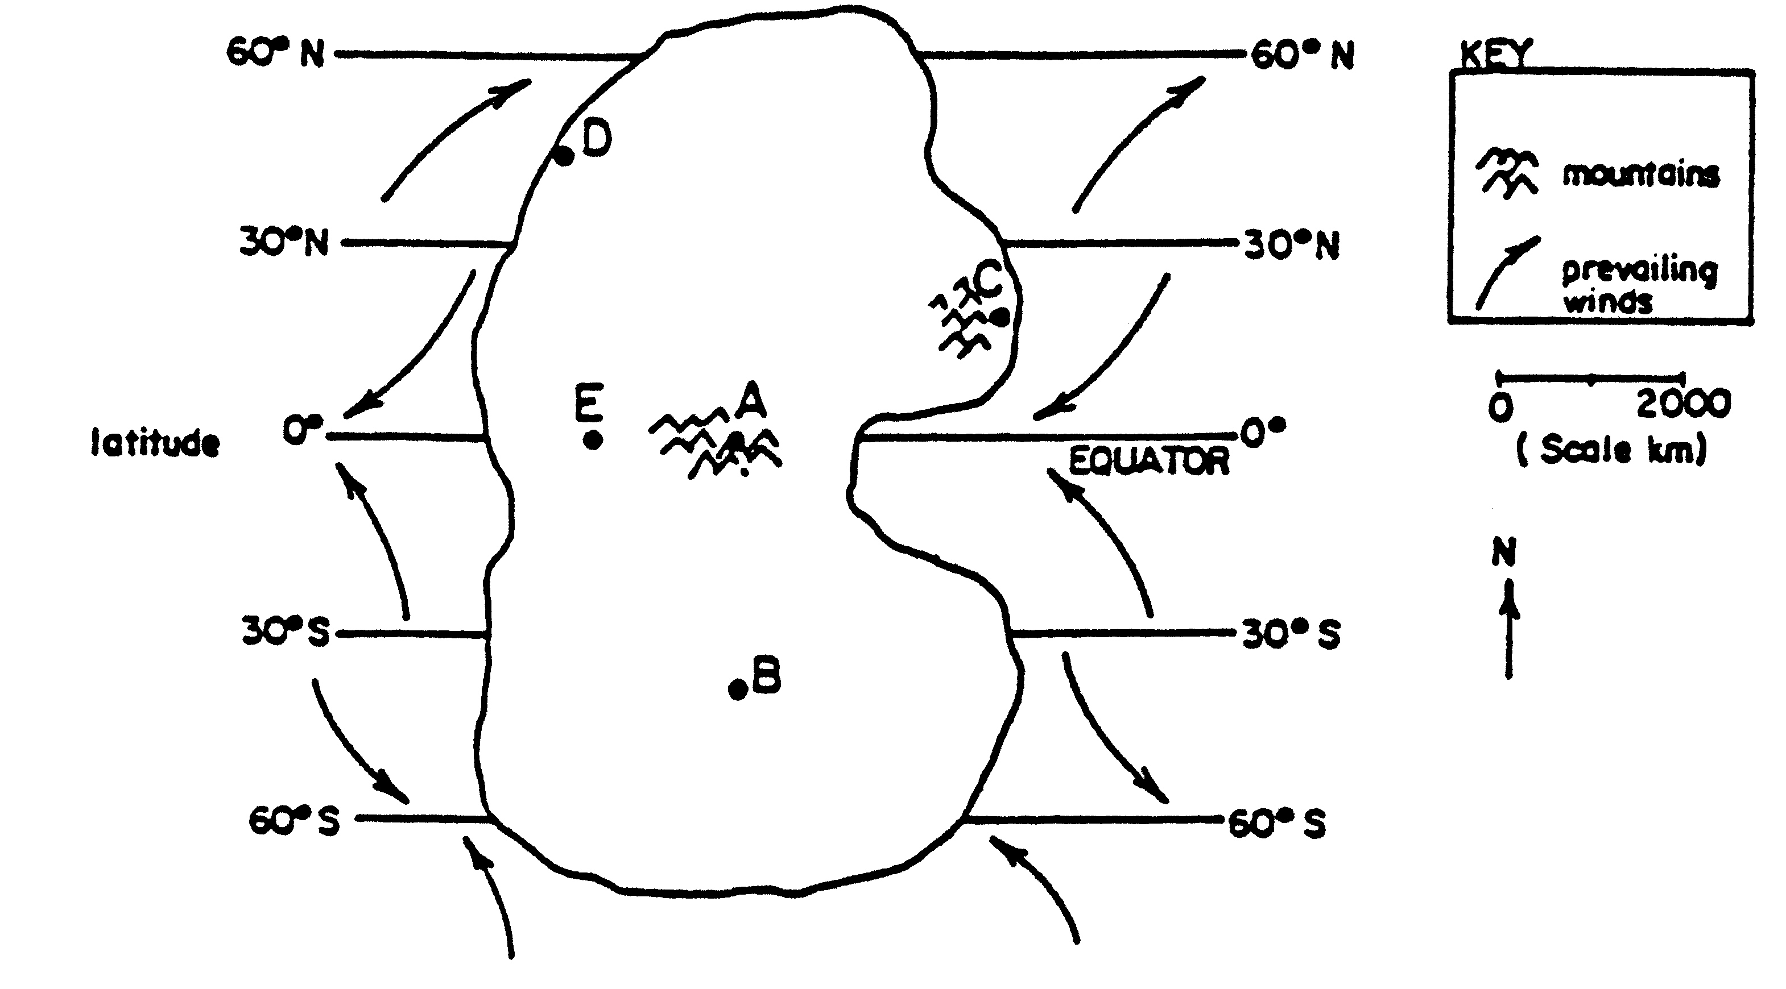
6. Which location on the imaginary continent
will probably have the highest
average temperatures for the year?
- A
- B
- D
- E

7. Which event temporarily slows or reverses surface ocean currents in the equatorial region of
the Pacific Ocean, causing a disruption of normal weather patterns?
(1) tsunami (3) El Niño
(2) volcanic eruption (4) deforestation
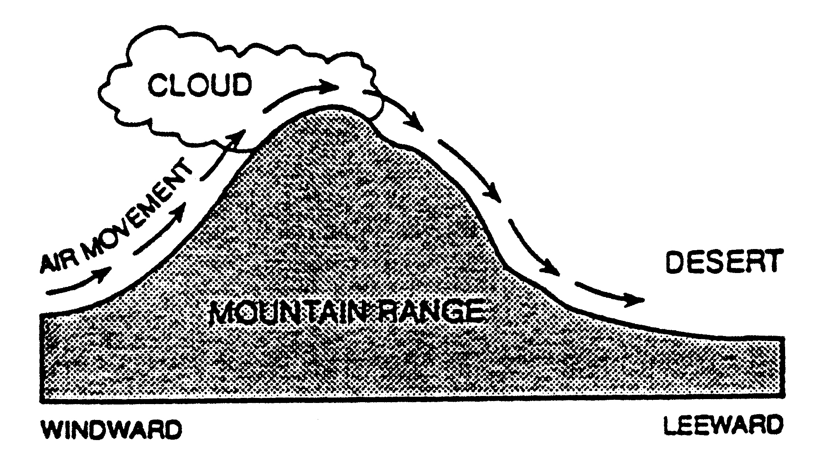
8. Which statement best explains why the windward side of a mountain range receive a large amount of
precipitation each year?

- Sinking air compresses and warms up.
- Sinking air expands and cools.
- Rising air compresses, warms, and dries out.
- Rising air expands, cools, and water vapor condenses.

9. Which area in New York State would most likely have the smallest annual temperature range?
(1) the Mohawk valley between Syracuse and Albany
(2) the Adirondack peaks southwest of Plattsburgh
(3) the Catskills west of Kingston
(4) the southern shore of Long Island

10. Which is the primary reason why bodies of water have a moderating effect on climate?
(1) Water temperatures are always lower than land temperatures.
(2) Water loses heat more slowly than land.
(3) Water surfaces are flatter than land surfaces.
(4) Water gains heat more rapidly than land.

Base your answers to questions 11 and 12 on the map below, which represents an imaginary continent. Locations A and B are on opposite sides of a mountain range on a planet similar to Earth. Location C is on the planet’s equator.
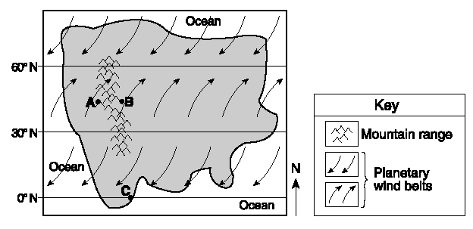
11. Compared to the climate at location A,
the climate at location B would most likely be
(1) warmer and more humid
(2) warmer and less humid
(3) cooler and more humid
(4) cooler and less humid

12. Location C most likely experiences
(1) low air pressure and low precipitation
(2) low air pressure and high precipitation
(3) high air pressure and low precipitation
(4) high air pressure and high precipitation

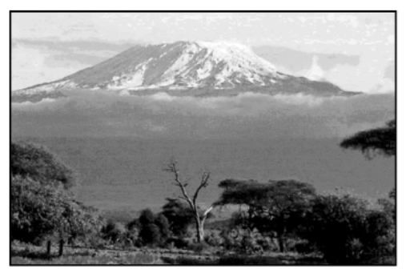
The photograph shows Mt. Kilimanjaro, a volcano in Africa.

13. Which climate factor is responsible for the snow seen
on Mt. Kilimanjaro?
(1) high latitude
(2) high elevation
(3) nearness to a cold ocean current
(4) nearness to a high-pressure weather center

The diagram below shows the positions of cities of Seattle and Spokane, Washington. Both cities are located at approximately 48º North latitude, and they are separated by the Cascade Mountains.
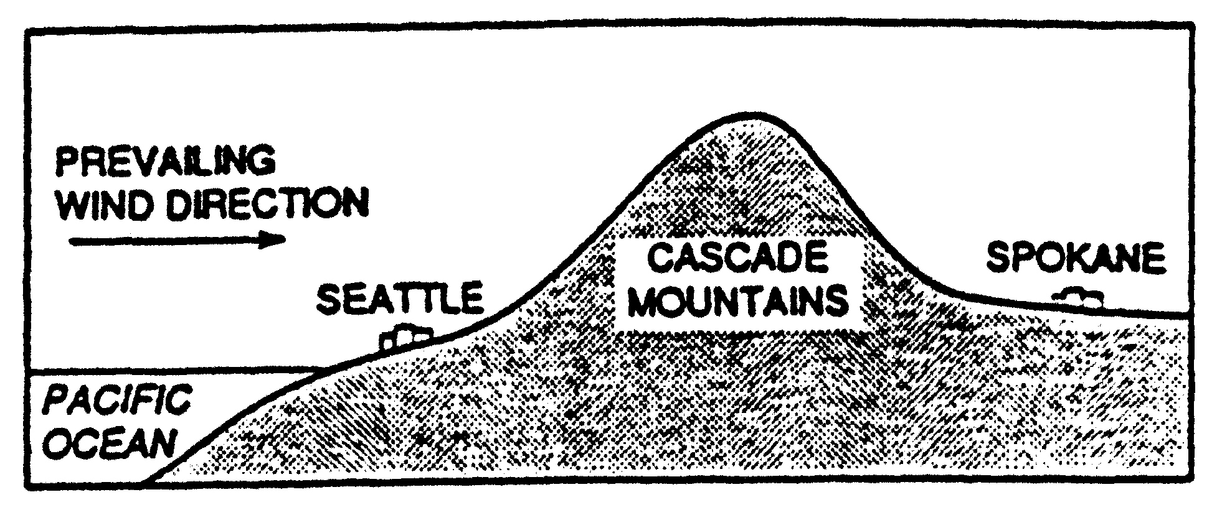

14. How does the climate of Seattle compare with the climate of Spokane?
(1) Seattle – hot and dry (3) Seattle – cool and humid
Spokane – cool and humid Spokane – warm and dry

(2) Seattle – hot and humid (4) Seattle – cool and dry
Spokane – cool and dry Spokane – warm and humid

15. What controls the direction of movement of most surface ocean currents?
(1) The Moon (3) density differences at various ocean depths
(2) prevailing winds (4) varying salt content in the ocean

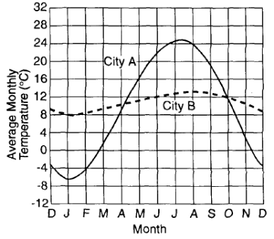
16. The graph below shows the average monthly
temperatures for two cities, A and B, which are both
located at 41° north latitude.

Which statement best explains the difference in the
average yearly temperature range for the two cities?
(1) City B is located in a different planetary wind belt.
(2) City B receives less yearly precipitation
(3) City B has a greater yearly duration of insolation.
(4) City B is located near a large body of water.

17. Which map correctly shows the general pattern of flow of prevailing surface winds near the
Equator on March 21?
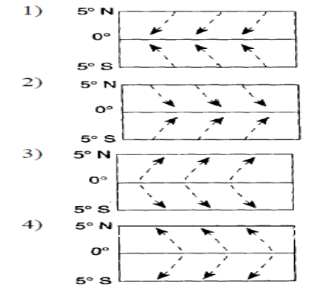

Topic: Climate and Moisture
Aim:

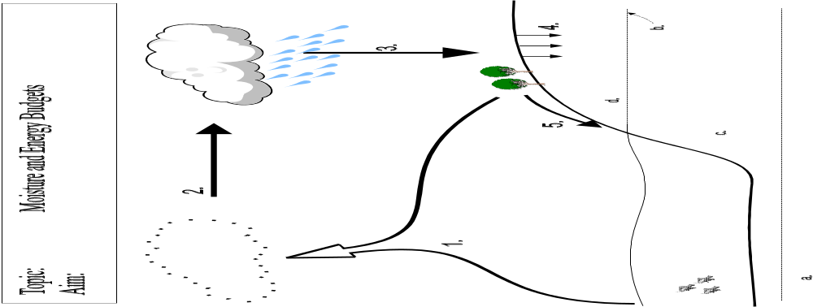
Condensation
(gas → liquid)

visible water droplets
invisible water vapor

Precipitation

Evaporation (mainly from oceans)
+ Transpiration (moisture from plants)
EVAPOTRANSPIRATION

4.

d. Zone of Aeration
c.

b. Zone of Saturation

a. Impermeable Zone - solid rock (bedrock) or a layer of soil that does not allow water to pass through

Water Cycle Review

1. The letters A through D in the cross section below represent four of the processes that are part
of the water cycle.
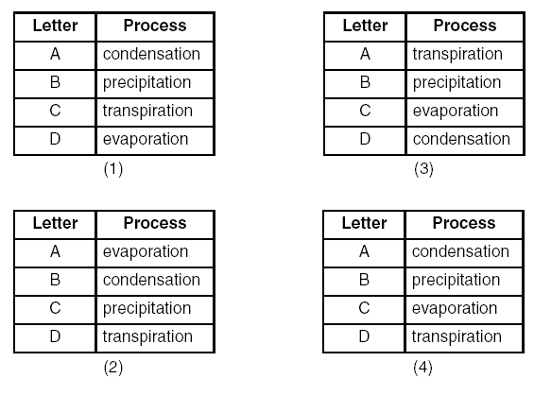
Which table correctly matches each letter with the
process that it represents?
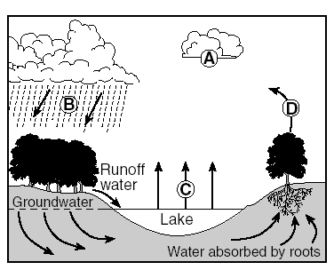

2. The water table usually rises when there is
(1) a decrease in the amount of infiltration
(2) a decrease in the amount of surface area covered by vegetation
(3) an increase in the amount of precipitation
(4) an increase in the slope of the land

3. Most moisture enters the atmosphere by the processes of
(1) convection and conduction (3) condensation and radiation
(2) reflection and absorption (4) transpiration and evaporation

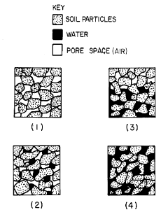
4. Which diagram best illustrates the condition of the soil below the water table?

Base your answers to questions 5 and 6 on the diagram below of the water cycle.
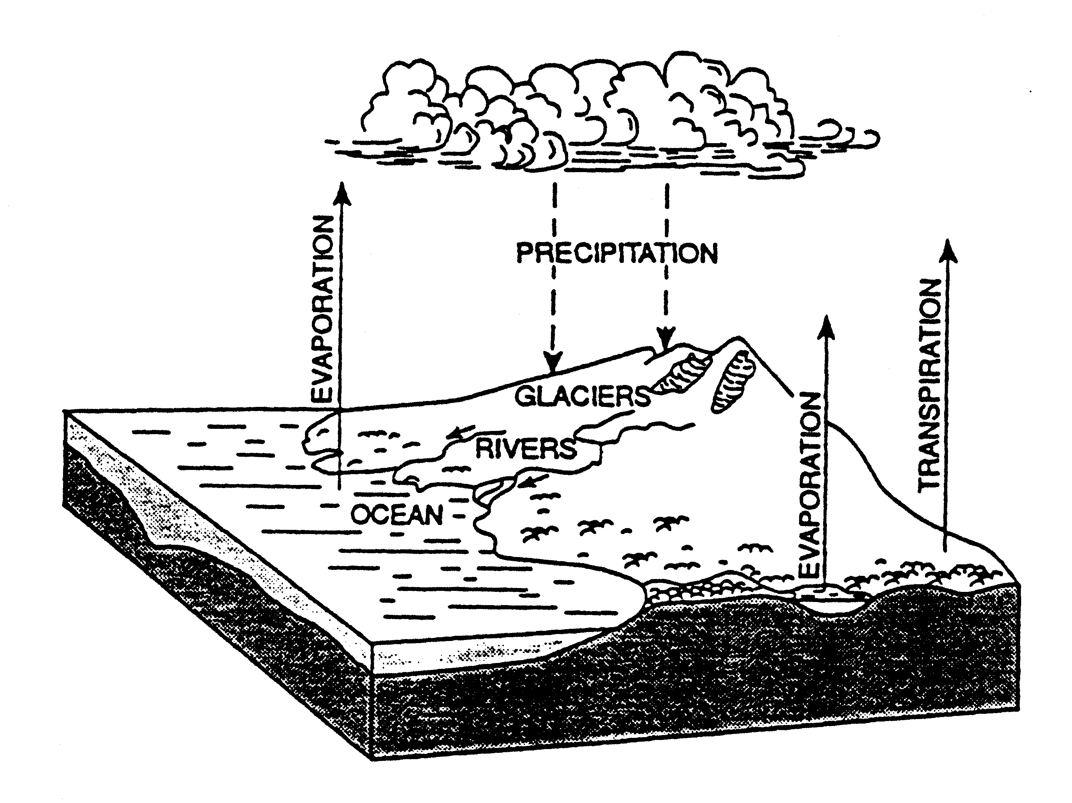
5. By which process does most water vapor
enter the atmosphere?
(1) evaporation from lakes and rivers
(2) evaporation from ocean surfaces
(3) evapotranspiration from land areas
(4) sublimation from polar ice and snow

6. The small arrows drawn near the rivers represent
(1) capillarity (3) absorption
(2) runoff (4) infiltration

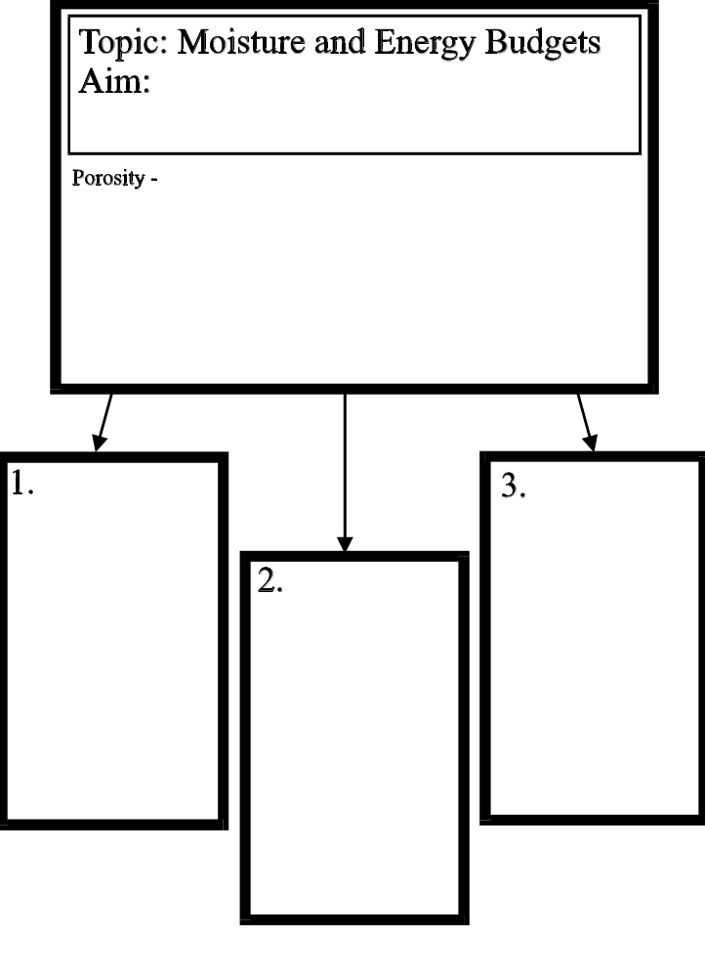
Topic: Climate and Moisture
Aim:

POROSITY -
a. _________________________________________________________________
b. _________________________________________________________________
c. _________________________________________________________________

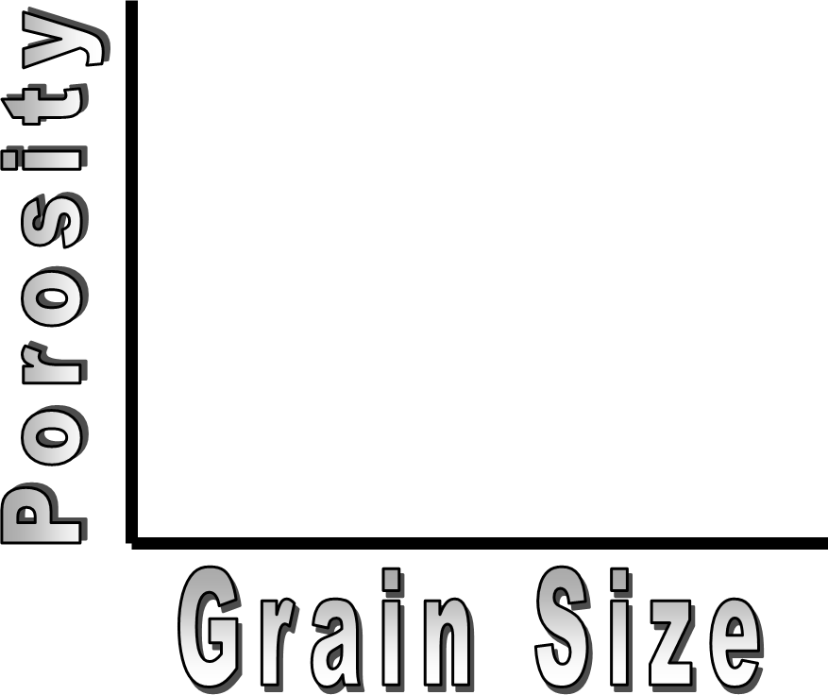
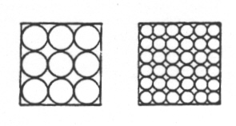

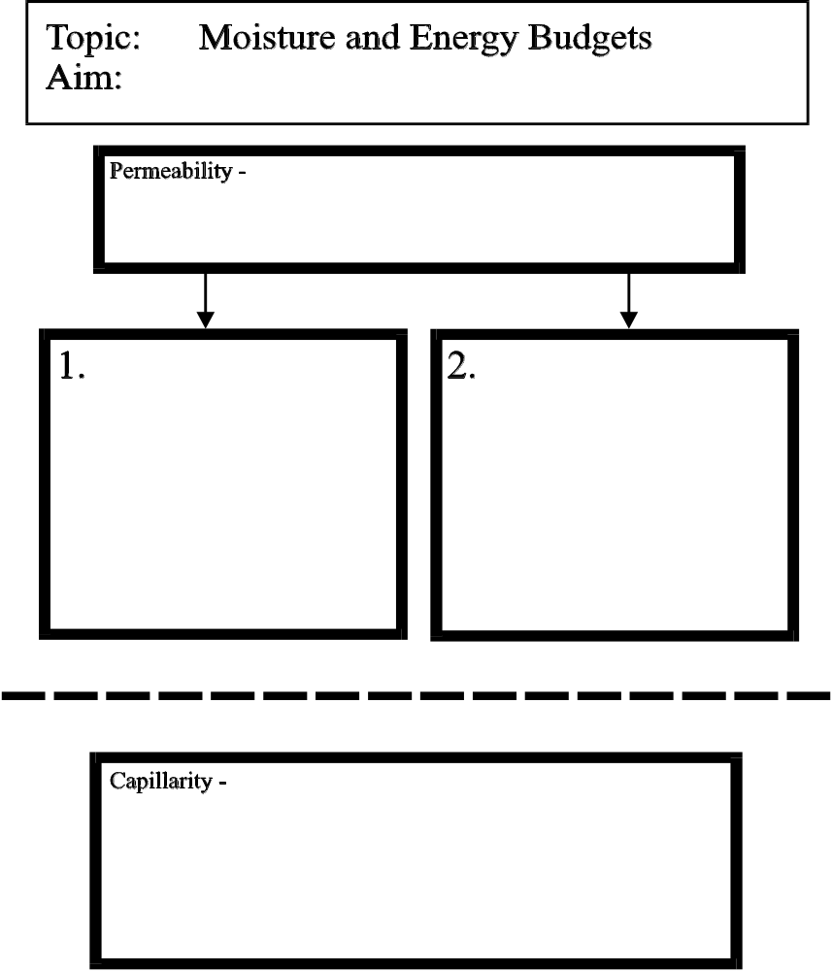
Topic: Climate and Moisture
Aim:

PERMEABILITY -

CAPILLARITY -

WATER RETENTION -

Topic: Climate and Moisture
Aim:

Remember that INFILTRATION and RUNOFF are opposites. If a factor allows for more infiltration, there will be less runoff. If a factor causes more runoff, there will be less infiltration.
1. Slope | As slope increases (becomes more steep),  the amount of runoff _____________________.
2. Permeability | As permeability of the soil increases,  the amount of infiltration _____________________.
3. Saturation | If the ground becomes saturated,  water will have to _____________________.
4. Rate of  Precipitation | If precipitation is falling hard and fast, the ground cannot absorb  it quick enough and more water will ______________.
5. Temperature  of the Ground | When the ground becomes frozen,  more water will _____________________
6. Vegetation | Plants’ roots create more openings for water and increase the amount  of _______________________.  Plants stems also act as barriers and reduce the amount of  ____________________.
Water in the Ground Review

1. Which graph best represents the relationship between soil permeability rate and infiltration when all other
conditions are the same?
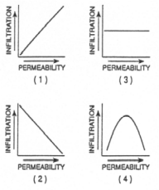

Use the diagram below to answer questions 2-5.
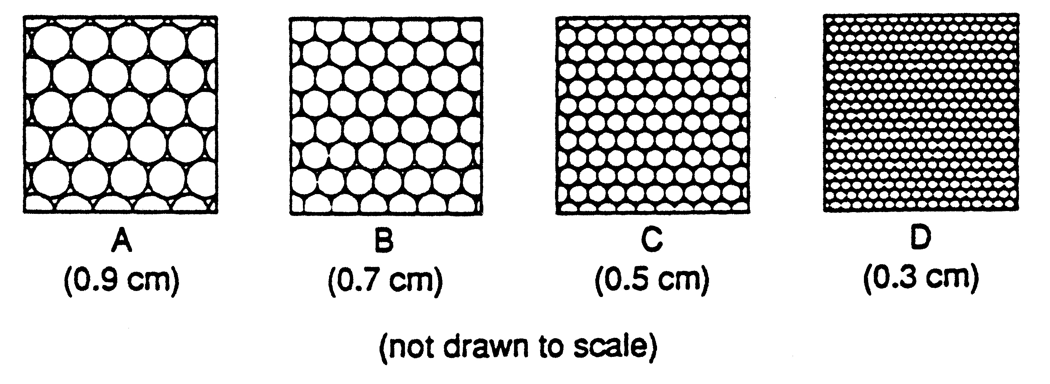

2. Which graph best represents the capillarity of the soil samples?
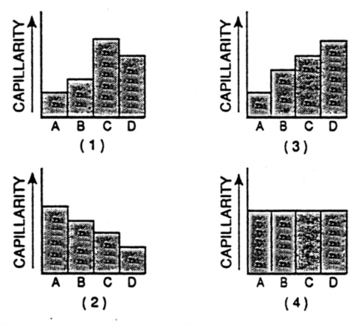

3. Water can infiltrate soil if it is
1 impermeable and saturated 3 permeable and saturated
2 impermeable and unsaturated 4 permeable and unsaturated

4. Which sample has the greatest permeability?
1 A 3 C
2 B 4 D

5. Some particles from sample D are mixed with particles from sample A. Compared to the original porosity
of sample A, the porosity of the resulting mixture will be
1 less 2 greater 3 the same

6. The diagram below represents two identical containers filled with samples of loosely packed sediments.
The sediments are composed of the same material, but differ in particle size. Which property is nearly
the same for the two samples?
1 infiltration rate
2 porosity
3 capillarity
4 water retention

7. Which is most important in determining the amount of groundwater that can be stored within a rock?
1 the rock’s geologic age 3 the rock’s porosity
2 the rock’s hardness 4 the rock’s color

8. Apartment buildings and parking lots completely cover an area that was once an open, grass-covered
field. What factor most likely increased because of this construction?
1 capillarity 3 infiltration into the ground
2 runoff 4 the level of the local water table

9. Which type of soil would water infiltrate most quickly?
1 silt 3 fine sand
2 pebbles 4 fine clay

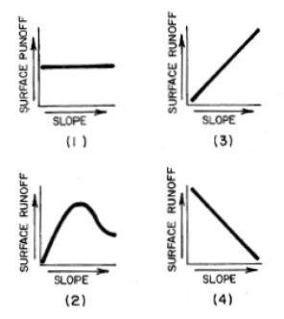10. Which graph best describes the relationship
between the slope of the land and the amount
of surface runoff during a period of heavy rainfall?

11. The graph to the right represents soil permeability.
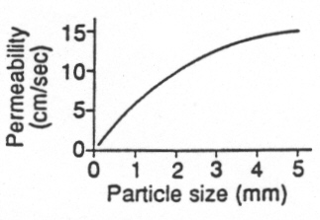
As particle size increases, permeability
1 decreases
2 increases
3 remains the same

12. During a heavy rainstorm, runoff is most likely to occur if the surface soil is
(1) firmly packed clay-sized particles
(2) loosely packed sand-sized particles
(3) covered by trees, shrubs, and grasses
(4) unsaturated and has a gentle slope

Climate and Moisture Practice Exam

1. Which two variables are the best to use when describing climate of a region?
1 wind direction and temperature 3 temperature and moisture
2 wind speed and moisture 4 air pressure and elevation

2. The Canaries Ocean Current is a
1 warm current that affects North America.
2 cold current that affects the east coast of South America.
3 warm current that affects northwest coast of Africa.
4 cold current that affects the northwest coast of Africa.

3. According to the Planetary Wind Chart, most of the world’s deserts are located at
1 0º latitude 3 30º North latitude
2 60º North latitude 4 60º South latitude

4. The Equator is a zone on Earth where winds
1 converge and rise 3 diverge and sink
2 converge and sink 4 diverge and rise

5. Two locations, one in northern Canada and one in the southwestern United States, have
different climates. The location in Canada is classified as a humid climate and the location in the
United States be classified as an arid (dry) climate. The best explanation for this is that
1 the location in Canada is colder
2 the location in the SW United States does not receive that much precipitation
3 the location in Canada on the leeward side of a mountain
4 the location in the SW United States is colder

6. Which statement best explains why it rains on the windward side of a mountain range?
1 Dry, sinking air compresses and warms. 3 Moist, rising air compresses and warms
2 Dry, sinking air expands and cools. 4 Moist, rising air expands and cools

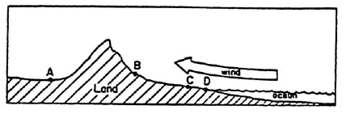
7. If the wind direction in the diagram below shows the prevailing winds, which location probably
the driest region?
1 A
2 B
3 C
4 D

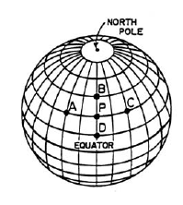
8. Which location has a highest average yearly temperature?
1 A
2 B
3 C
4 D

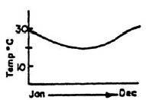
9. The graph below represents the average temperate of a city for
each month of the year. Where is this city most likely located?
1 in the Northern Hemisphere, in a middle latitude
2 in the Southern Hemisphere, near the South Pole
3 on a coast, just north of the Equator
4 on a coast, just south of the Equator

10. The deserts of the southwest U.S. receive little rainfall primarily because they are located
1 at an elevation below sea level 3 on the leeward side of mountain ranges
2 far from the ocean 4 on the windward side of mountain ranges

11. By which two processes does water leave the Earth and enter the atmosphere?
1 runoff and infiltration 3 precipitation and condensation
2 evaporation and transpiration 4 evaporation and precipitation

12. The upper boundary of groundwater is known as
1 groundwater 3 water table
2 zone of saturation 4 zone of aeration

13. As latitude increases the average temperatures of a region
1 decrease 2 increase 3 remain the same

14. Flash flooding often occurs in city areas because
1 runoff decreases during precipitation
2 groundwater storage is usually very large
3 roads, pavements, and buildings reduce the infiltration of water into the ground
4 the heat generated by city areas decreases actual evapotranspiration

15. Most of the world’s deserts are located
1 in belts of high pressure 3 in belts of low pressure
2 in belts of moderate pressure 4 randomly over the Earth

16. The leeward side of a mountain usually has a climate that is both
1 warm and wet 3 cool and wet
2 warm and dry 4 cool and dry

17. A coastal location, as compared to an inland one, will have
1 warmer summers and cooler winters 3 cooler summers and cooler winters
2 warmer summers and warmer winters 4 warmer winters and cooler summers

18. Which situation would cause a drop in the local water table?
1 a period of heavy precipitation 3 soil that is saturated
2 a warm period with little precipitation 4 increased infiltration of water created by melting snow

19. Clouds are formed by the process of
1 condensation 3 precipitation
2 evaporation 4 convection

20. Which location in New York would have the smallest range of temperatures?
1 Syracuse 3 Riverhead
2 Rochester 4 Albany

21. Which process cleans the atmosphere by bringing water and dust particles back to Earth?
1 precipitation 3 condensation
2 evaporation 4 transpiration

22. A soil sample with a high percentage of open space between grains must
1 have low permeability 3 have mixed grain sizes
2 be porous 4 show a high amount of capillarity

23. Which graph best represents the relationship between particle size of a loose material and the
loose material’s permeability?
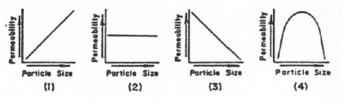

24. When rain falls on a soil surface, flooding at that location would most likely occur if the
1 soil surface is permeable 3 soil surface is covered with vegetation
2 soil pore spaces are filled to capacity 4 infiltration rate exceeds the precipitation rate

25. Which size particles would have the greatest capillarity?
1 clay 3 pebbles
2 silt 4 sand

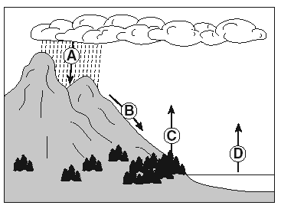
26. The arrows in the diagram below represent the
movement of water in the water cycle.

Which arrow represents the process of transpiration?
(1) A (3) C
(2) B (4) D

27. Which soil sample would have the greatest permeability?
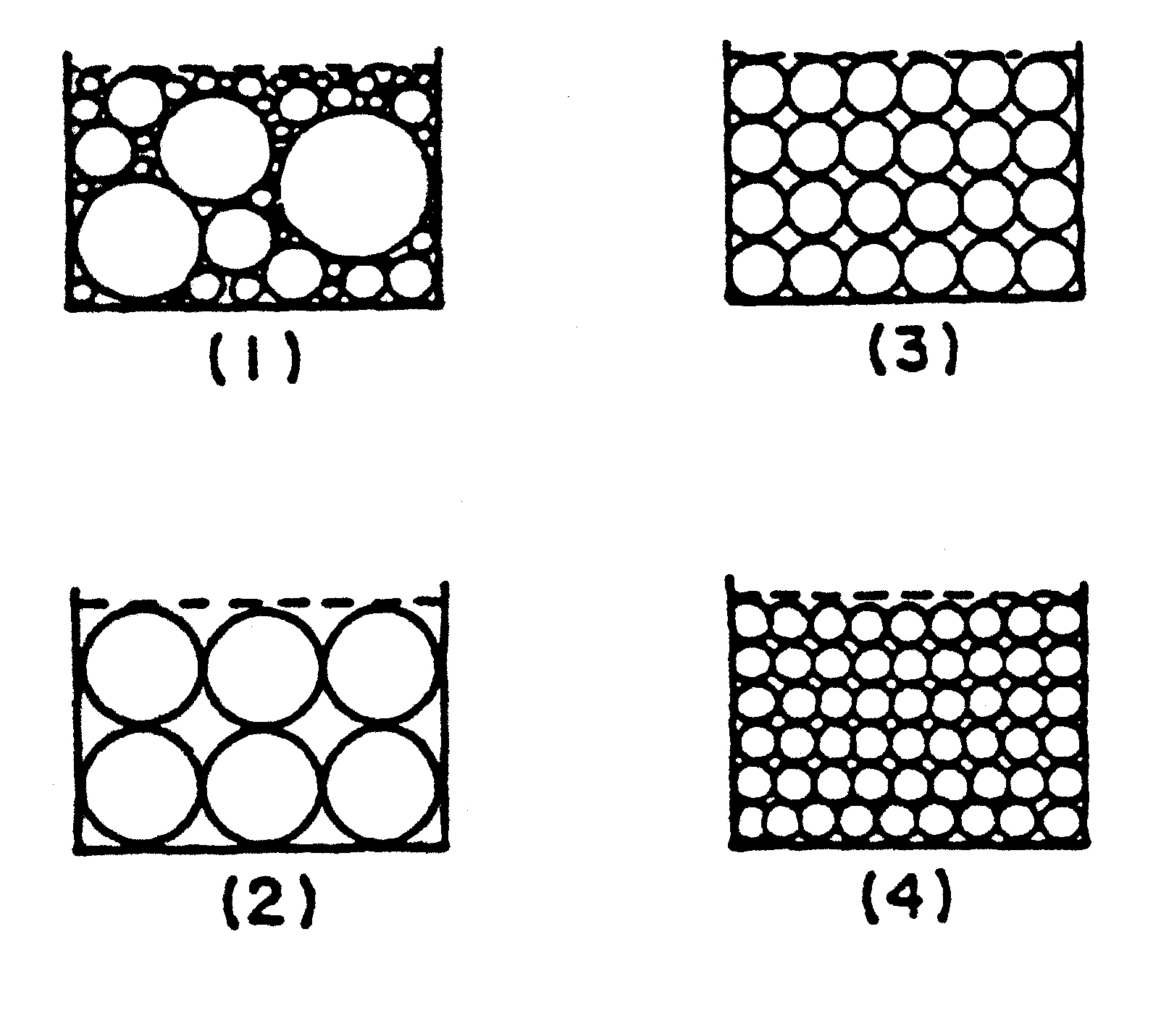

The diagram below shows columns A, B, C, and D that contain different sediments.
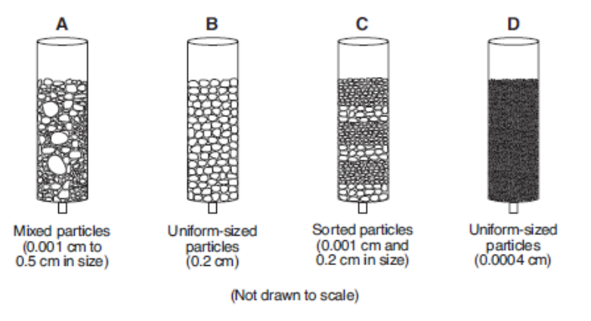
Equal volumes of water were poured through each column.

28. Which column of sediment retained the most water?
(1) A (3) C
(2) B (4) D

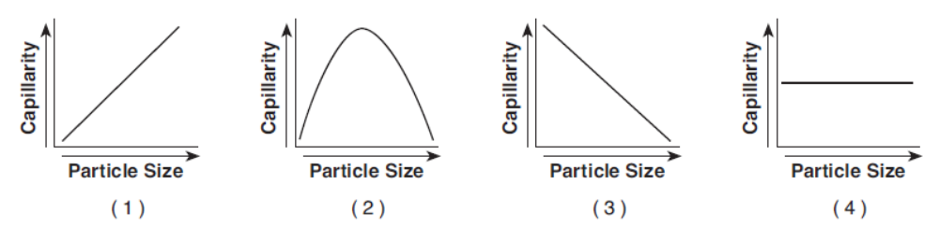
29. Which graph shows the general relationship between soil particle size and the capillarity of the soil?

30. The flowchart below shows part of Earth’s water cycle. The question marks indicate a part of the flowchart
that has been deliberately left blank.
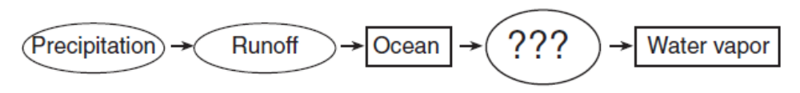

Which process should be shown in place of the question marks to best complete the flowchart?
(1) condensation (3) evaporation
(2) deposition (4) infiltration

