Topic IV
Part 3
Laws of Planetary Motion and
the Moon

Topic: Laws of Planetary Motion
Aim:

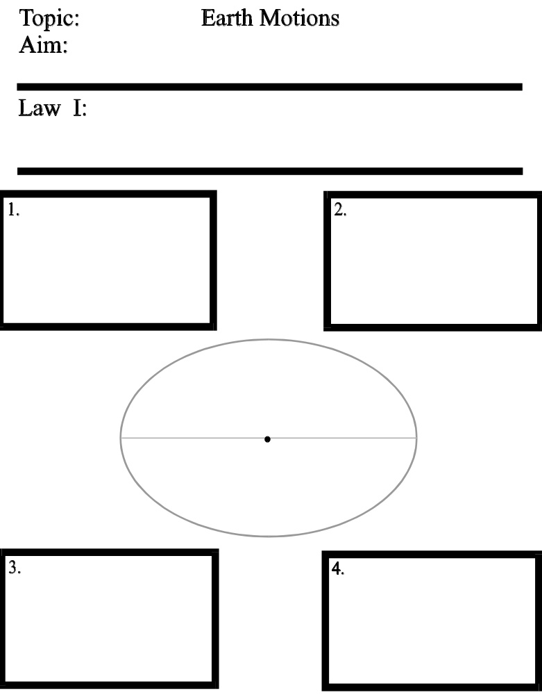

FOCI - (plural of focus)
two points on the major axis (longest axis drawn through the ellipse) located on opposite sides of the center point and equidistant from the center point. (See diagram below)
Eccentricity –

A numerical measurement of “how oval” an ellipse is.

The more eccentric an ellipse is, the more oval-shaped it is.

the ellipse-shaped orbit on which a celestial object travels

major axis
(longest line drawn through ellipse)

Focus 1 Focus 2

distance between foci

As the distance between the foci increases, the eccentricity of the ellipse also increases.

- lowest eccentricity value = 0
(geometric shape is a circle)
- highest eccentricity value = 1
(geometric shape is a line)

Eccentricity formula: (ESRT)

e =

Distance between the foci
Length of the major axis

d
L
e =

Eccentricity

You will need to use a ruler to do questions 1 and 2.

1. What is the eccentricity of the ellipse shown to the right?

(1) 1.000 (3) 0.256
(2) 0.524 (4) 0.133

2. The diagram below represents the orbit of a spacecraft around the Sun.

a. What is the numerical eccentricity of the orbit
rounded to the nearest thousandths?

________________________

b. According to the Earth Science Reference Tables,
the eccentricity of the spacecraft’s orbit is
(1) the same as the Earth’s orbital eccentricity
(2) more eccentric than Earth's orbit, but less eccentric than Mars' orbit
(3) more eccentric than the orbit of any planet in the Solar System
(4) less eccentric than the orbit of any planet in the Solar System

3. Which of the following planets has the most elliptical orbit?
(1) Saturn (3) Venus
(2) Neptune (4) Mercury

4. Which of the following planets has the most circular orbit?
(1) Mercury (3) Venus
(2) Neptune (4) Earth

5. Orbits with a higher eccentricity value
(1) are more elliptical and appear more oval-shaped
(2) are less elliptical and appear more circular
(3) are more elliptical and appear more circular
(4) are less elliptical and appear more oval-shaped

Topic: Laws of Planetary Motion
Aim:

NEWTON’S LAW OF UNIVERSAL GRAVITATION

The gravitational attraction between two objects is greatest when:
1. _____________________________________________
2. _____________________________________________

KEPLER’S SECOND LAW OF PLANETARY MOTION

When orbiting the Sun, a planet sweeps out equal areas in an equal amount of time.
This REALLY means:

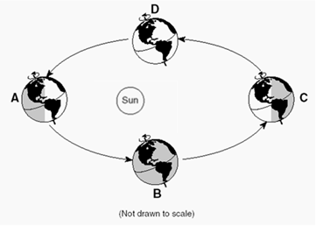

The Sun has a greater
apparent diameter (looks bigger) when viewed from Earth at perihelion because it is closer.
The Sun has a smaller apparent diameter when viewed from Earth at aphelion because it is farther.

KEPLER’S THIRD LAW OF PLANETARY MOTION

Outer planets have a longer period of revolution than inner planets.

This is true because:
1. _____________________________________________
2. _____________________________________________

Kepler’s Laws of Planetary Motions,
Law of Universal Gravitation,
and Apparent Diameter (Size)

- What is the exact shape of the Earth’s orbit around the Sun?
- The orbit is a slightly eccentric ellipse.
- The orbit is a very eccentric ellipse.
- The orbit is an oblate spheroid
- The orbit is a perfect circle.

- The gravitational attraction between the Earth and the Sun is greatest at the time when
- Earth is farthest from the Sun
- Earth is closest to the Sun
- Northern Hemisphere is receiving maximum intensity of insolation
- Northern Hemisphere is receiving maximum duration of insolation

- As the distance between the Earth and a satellite increases, the gravitational attraction between them will
(1) decrease (2) increase (3) remain the same

- As the distance between the Earth and the Sun decreases, the velocity of the Earth in its orbit
(1) decreases (2) increases (3) remains the same

- Planet A has a greater mean distance from the Sun than Planet B. On the basis of this fact, which further comparison can be correctly made between the two planets?
- Planet A is larger.
- Planet A’s revolution period is longer.
- Planet A’s speed of rotation is greater.
- Planet A’s day is longer.

- The top views of four possible orbits for a planet revolving around a star are shown below. The distances from the star to each orbit are drawn to scale. In which orbit would the greatest changes in orbital velocity occur as the planet makes one revolution?

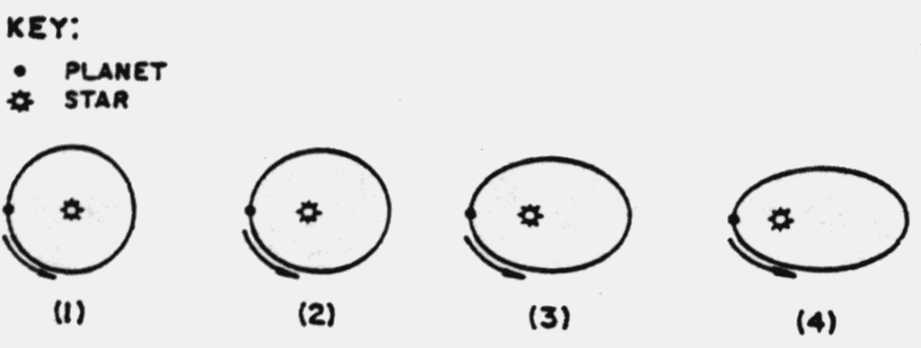

- The diagram shows the orbits of planets A and B in a star-planet system.

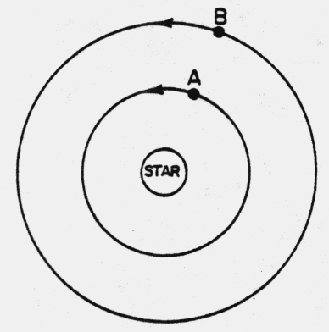The period of revolution for planet B is 40 days.
The period of revolution for planet A most likely is

- less than 40 days
- greater then 40 days
- 40 days

- The diagram below represents the orbit of a planet around the Sun.
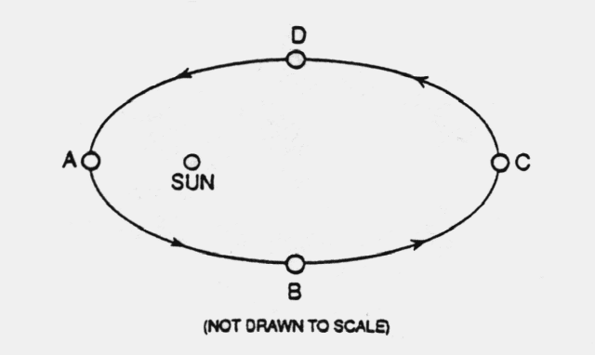

At which location is the gravitational attraction between the Sun and the planet the greatest?
- A (3) C
- B (4) D

- The force of gravity between two objects will be greatest if their masses are
- small and they are far apart
- small and they are close together
- large and they are far apart
- large and they are close together

10. Which planet has an orbital eccentricity most like the orbital eccentricity of the Moon?
(1) Venus (3) Mars
(2) Saturn (4) Mercury

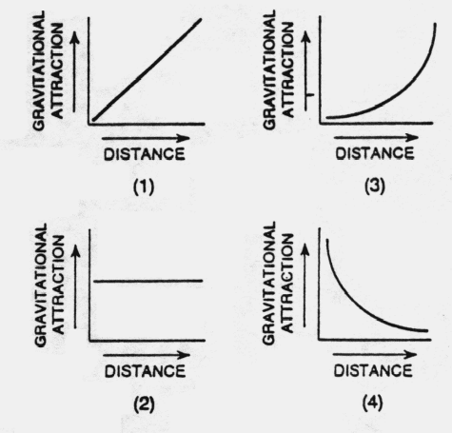11. Which graph best represents the relationship between the gravitational attraction of two objects
and their distance from each other?

12. The diagram below shows a satellite in an elliptical orbit around the Earth.
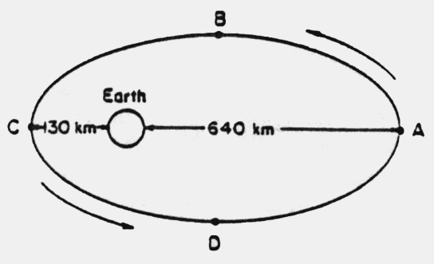

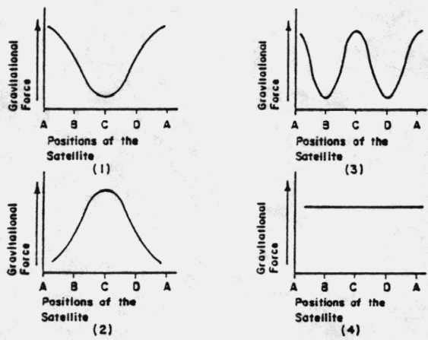Which graph best approximates the gravitational force between the Earth and the satellite at
positions A through D?

13. As the Moon in its orbit moves closer to Earth, the Moon’s apparent size as measured from Earth will
(1) decrease (2) increase (3) remain the same

Topic: The Moon
Aim:

a. Moon’s period of rotation =

b. Moon’s Period of revolution =

c. we always see the same side of the moon because
the Moon’s rotation and revolution periods are equal.

1. What are
the motions
of the Moon?

2. What causes
the phases
of the Moon?

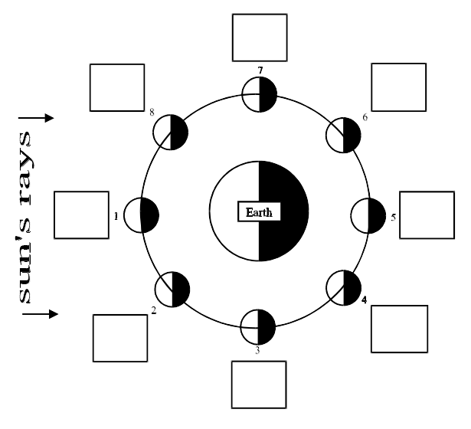
The numbered positions represent where the Moon is in its orbit around the Earth

The circles that you shaded illustrate the phase of Moon observed from the Earth when Moon is at that position.

Moon Phases

1. Name each of the phases of the Moon:

1 _________________
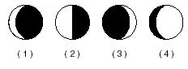
2 _________________
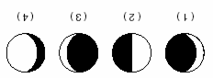
3 _________________
4 _________________

5 _________________
6 _________________
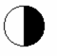
7 _________________
8 _________________

2. The phases of the Moon are caused by
(1) rotation of the Earth on its axis (3) revolution of the Moon around the Earth
(2) rotation of the Moon on its axis (4) revolution of the Earth around the Sun

3. The diagram below represents the Moon in its orbit, as viewed from above Earth’s North Pole.
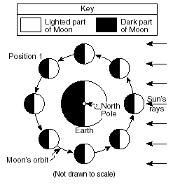
Position 1 represents a specific location of the Moon in its orbit.

Which phase of the Moon will be seen from
Earth when the Moon is at position 1?

4. The diagram below represents the Moon, the Earth, and the Sun’s rays. Point A is a location on
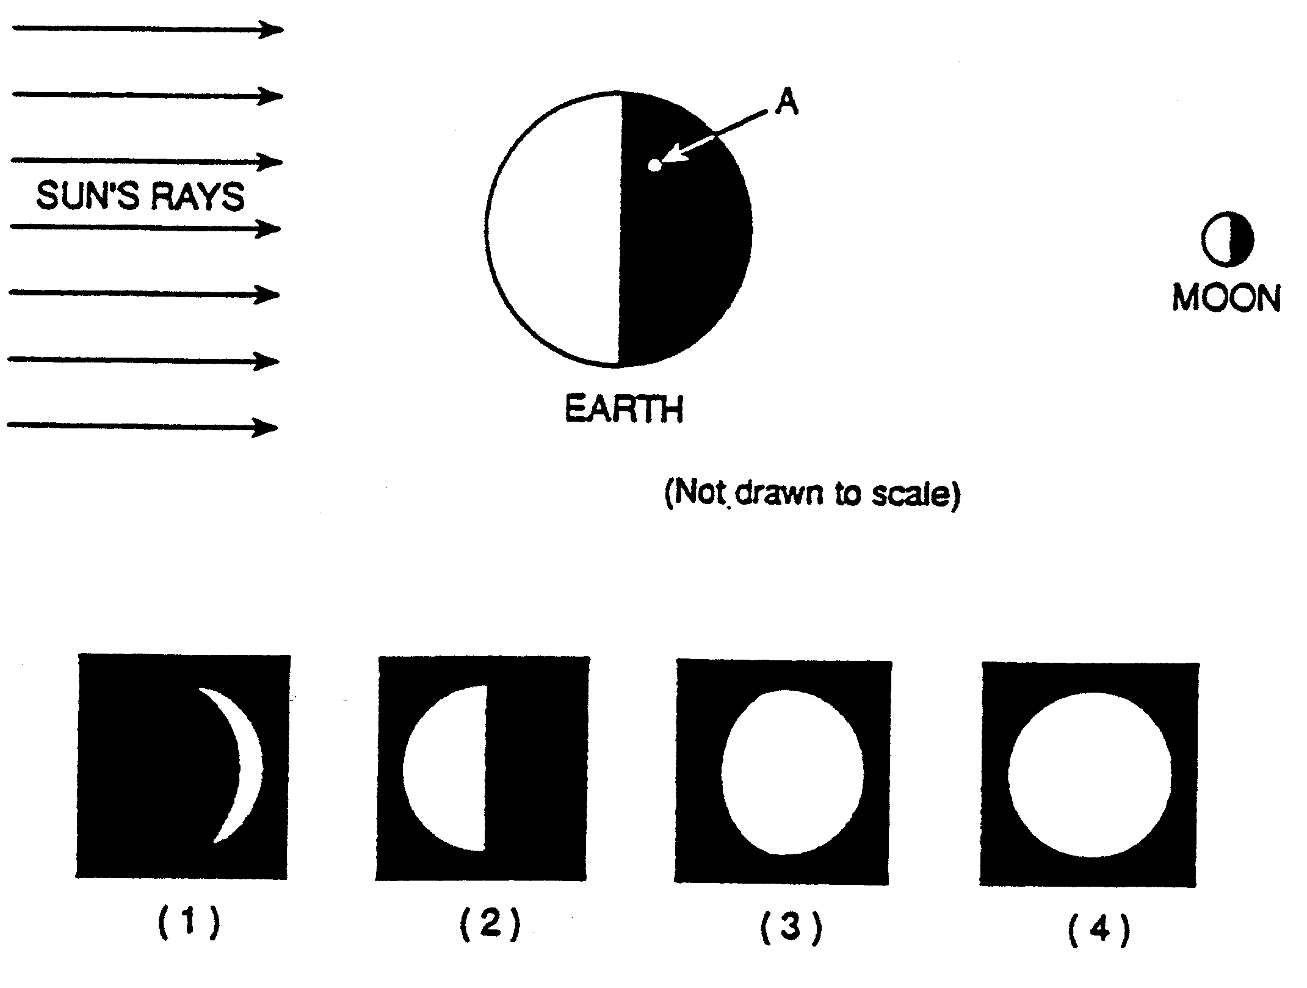
the Earth’s surface.

How does the Moon appear when observed from point A on the Earth?

5. A student observed the phases of the Moon observed from one location on the Earth on each of
the dates shown below.
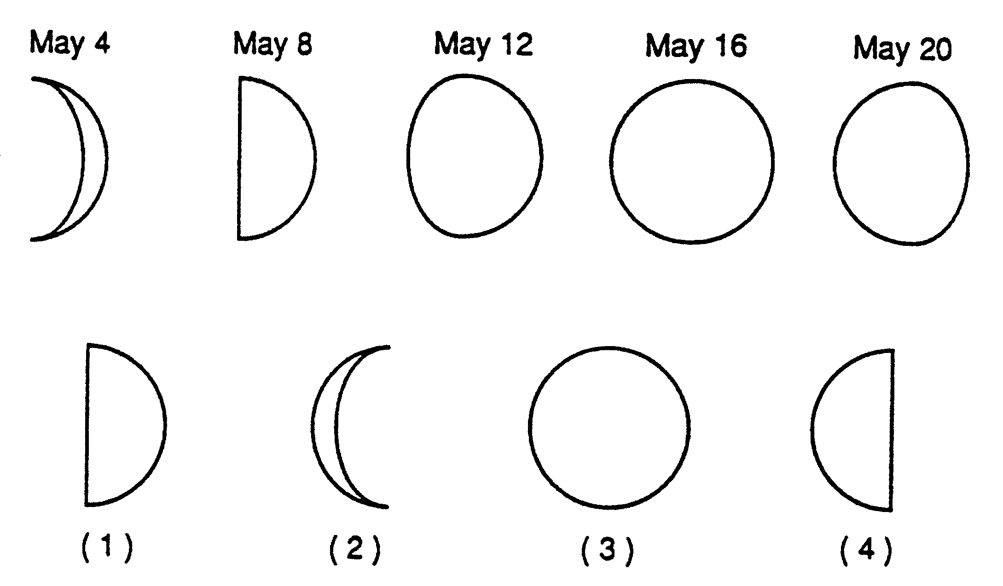

Which diagram best shows the Moon’s phase on May 24th?

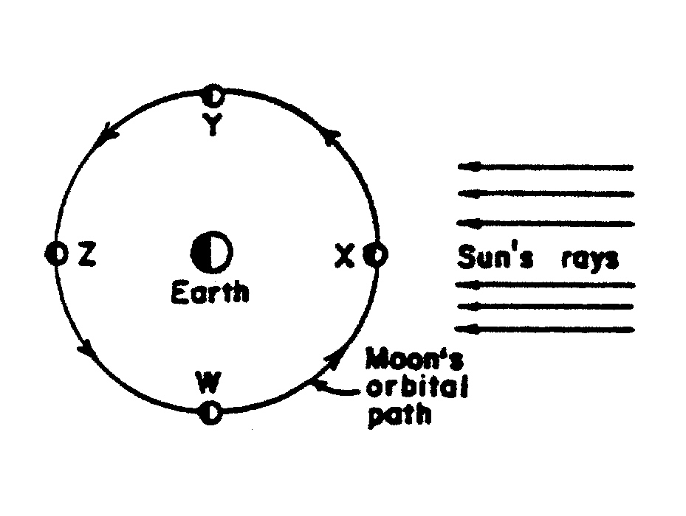

6. The diagram shows four positions
of the Moon in its orbit around the Earth.
In which position will the new moon phase
be seen from the Earth?

- W
- X
- Y
- Z

Topic: The Moon
Aim:

1.

2.

3.

DIAGRAM A
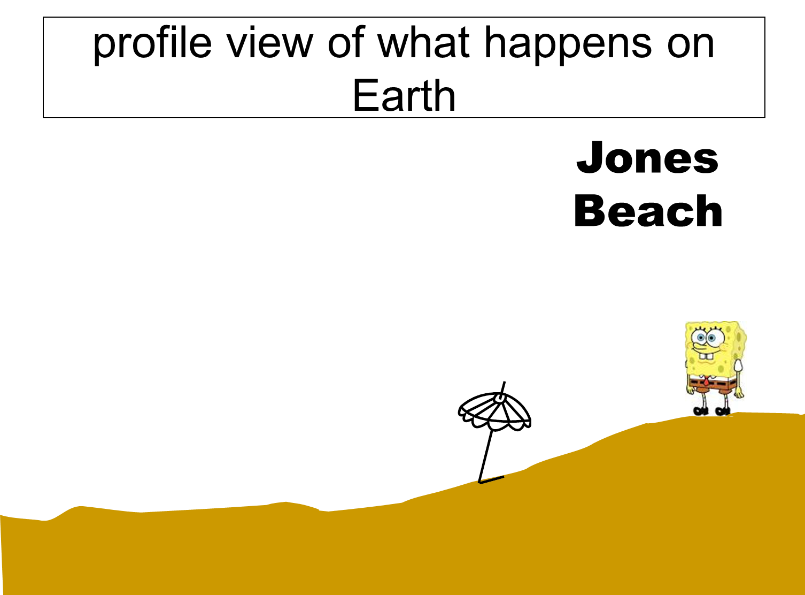
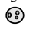

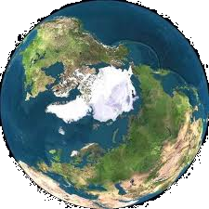

DIAGRAM B – a little more than 6 hours later …

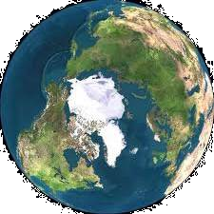

Topic: The Moon
Aim:

1. What is spring tide?

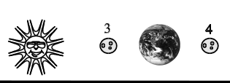
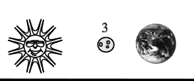

2. What is neap tide?

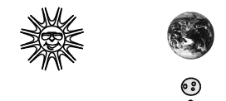
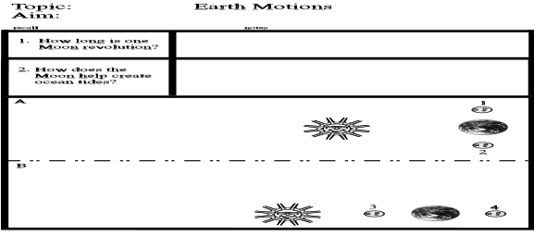

Special Note Concerning Eclipses: Eclipses do not occur every month because the Moon’s orbit is tilted (inclined) with respect
to Earth’s orbit. This prevents the Sun, Moon, and Earth from being perfectly aligned.

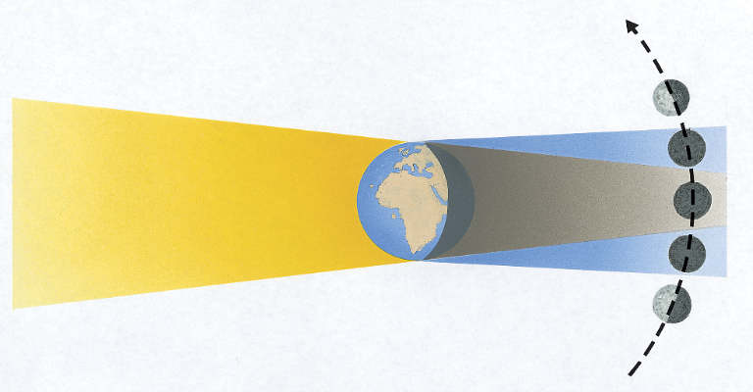
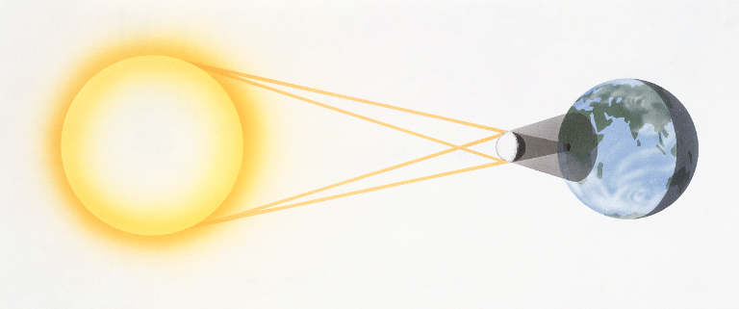
penumbra (lighter shadow) – partial eclipse
umbra (darker shadow) –
total eclipse
penumbra (lighter shadow) – partial eclipse
umbra (darker shadow) –
total eclipse

Topic: The Moon
Aim:

1.

2.

Moon Phases, Tides, and Eclipses

Questions 1-3:
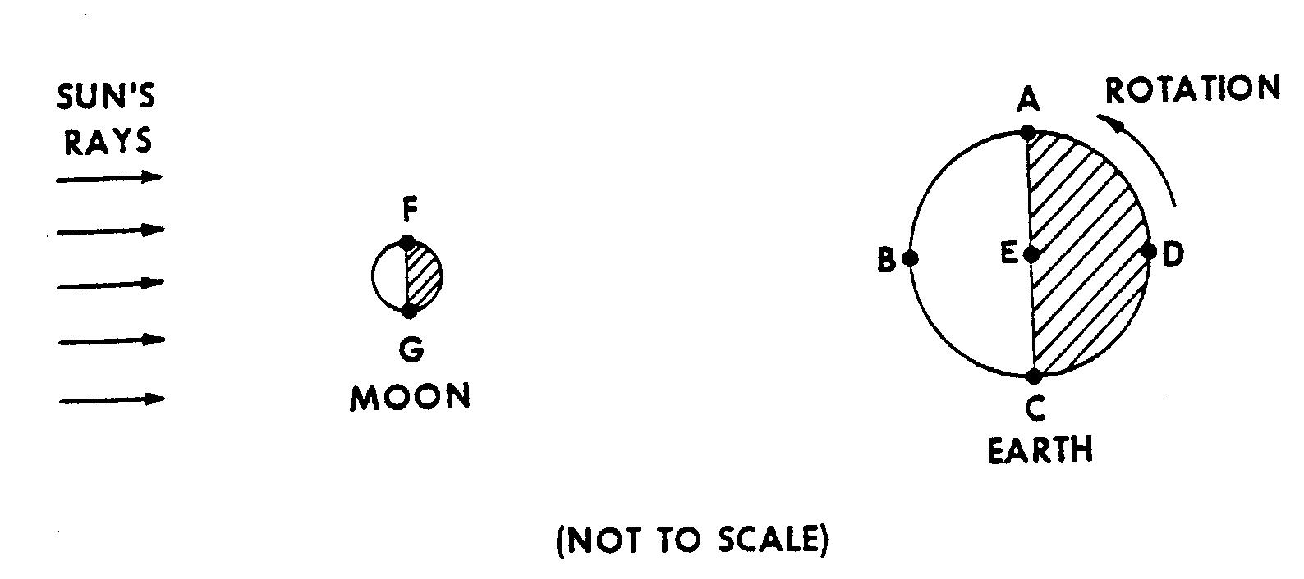
1. Which phase of the Moon would be
observed at position B when the
Earth, Sun, and Moon align as
shown in the diagram?
(1) full
(2) crescent
(3) gibbous
(4) new

2. Which positions on Earth would be experiencing a high tide?
(1) A and B (3) B and C
(2) A and C (4) B and D

3. Which other astronomical event could possibly occur in the alignment shown?
(1) a solar eclipse could be observed at position B
(2) a lunar eclipse could be observed at position B
(3) a lunar eclipse could be observed at position D
(4) a neap tide is occurring

4. A total lunar eclipse will occur when the Moon moves into the
(1) umbra of the Earth (3) penumbra of the Earth
(2) umbra of the Moon (4) penumbra of the Moon

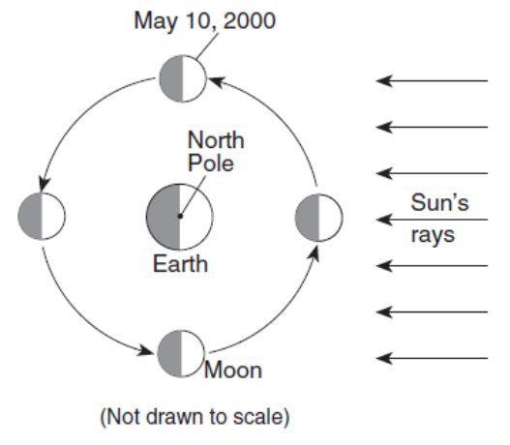
5. The diagram shows the Moon at four positions in its orbit
around Earth as viewed from above the North Pole.
The date of one of the four positions has been labeled.

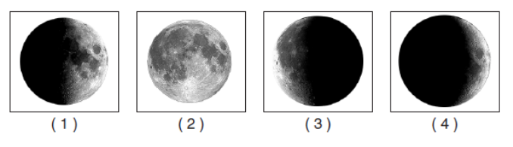
Which photograph shows the appearance of the Moon
as viewed by an observer in New York State on
May 17, 2000?

6. Approximately how many hours exist between two consecutive high tides?
(1) 3 hours (3) 12.5 hours
(2) 6 hours (4) 24 hours

7. The cyclic rise and fall of ocean tides on Earth is primarily caused by Earth’s rotation and the
(1) temperature differences in ocean currents (3) direction of Earth’s planetary winds
(2) revolution of Earth around the Sun (4) gravitational attraction of the Moon and the Sun

Base your answers to questions 8 through 10 on the world map below, which shows regions of Earth where a solar eclipse was visible on May 20, 1947. Locations A, B, C, and D are on Earth’s surface.
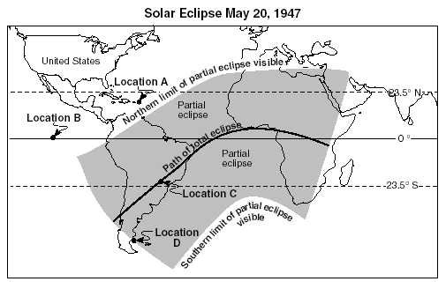
8. At which location could an observer have viewed
this total solar eclipse if the skies were clear?
(1) A (3) C
(2) B (4) D

9. Which statement best describes the visibility of this
eclipse from locations in New York State?
(1) A total eclipse was visible all day.
(2) A total eclipse was visible only from noon until sunset.
(3) A partial eclipse was visible only from noon until sunset.
(4) Neither a partial nor a total eclipse was visible.

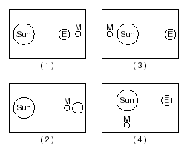

10. Which diagram best represents the positions of Earth (E),
the Sun, and the Moon (M) that created the solar eclipse?
(Diagrams are not drawn to scale.)

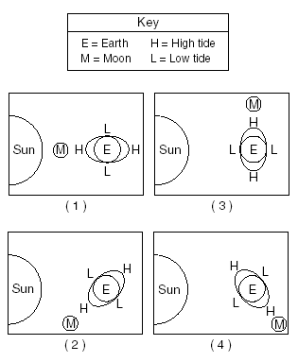

11. The diagrams below represent Earth’s ocean tides at four
different positions of the Moon.

Which diagram shows the Moon position that will produce
the highest high tides and the lowest low tides?
(The diagrams are not drawn to scale.)

12. The diagram shows Earth’s orbit around the Sun and different
positions of the Moon as it travels around Earth. Letters A through D
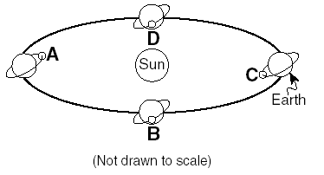
represent four different positions of the Moon.

An eclipse of the Moon is most likely to occur
when the Moon is at position
(1) A (3) C
(2) B (4) D

Base your answers to questions 13 and 14 on the calendar below, which shows the month of July of a recent year.
The dates of major Moon phases, as seen in New York State, are shown.
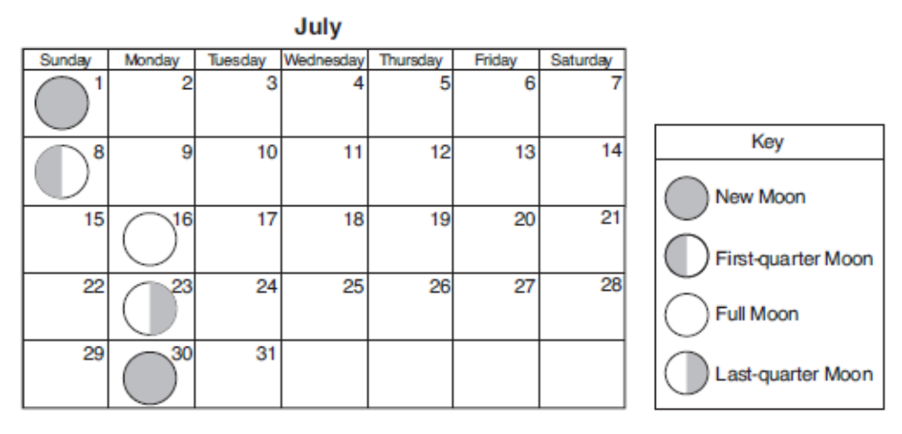


13. The diagram below represents the phase of the Moon observed from New York State one night during the month of July.

On which date was this phase of the Moon visible from New York State?
(1) July 4 (3) July 19
(2) July 11 (4) July 26

14. On which date will the next first-quarter Moon phase occur?
(1) August 6 (3) August 16
(2) August 10 (4) August 22

15. Eclipses do not occur every month because the Moon’s
(1) rate of rotation is 15° each hour (3) orbit is inclined to Earth’s orbit
(3) period of revolution is 27.3 days (4) period of rotation and period of revolution are the same

16. Why does the Moon’s gravity have a greater effect on Earth’s ocean tides than the Sun’s gravity?
(1) The Sun is composed mostly of gases. (3) The Moon is much closer to Earth.
(2) The Sun’s gravity influences more planets. (4) The Moon has a greater mass.

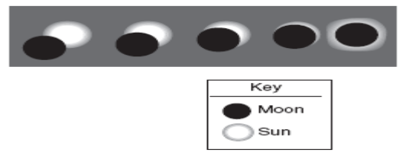
17. What is represented by the diagram below?

(1) changing phases of the Sun (3) stages in an eclipse of the Sun
(2) changing phases of the Moon (4) stages in an eclipse of the Moon

18. An observer recorded the times of three successive high tides at one Earth location as:
• 7:12 a.m.
• 7:38 p.m.
• 8:04 a.m.

What was the time of the next high tide?
(1) 8:12 p.m. (3) 8:38 p.m.
(2) 8:30 p.m. (4) 9:04 p.m.

Questions 19 and 20:
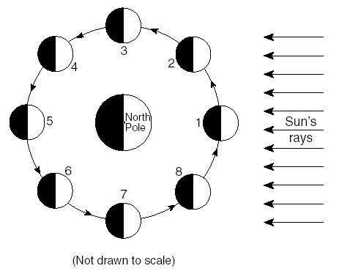
The diagram below shows the Moon as it revolves around Earth. The numbered locations represent different positions of the Moon in its orbit around the Earth.

19. Sketch in the circle to represent the phase
of the Moon that would be seen at position 8.

20. What the name of the phase when the Moon is at position 8?

_________________________________________________

21. The photographs below show the surface of the Moon as seen from Earth over an 80-minute period
during a single night.
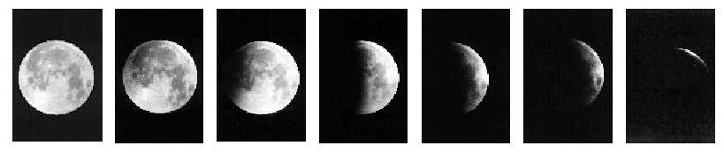

Which motion is responsible for this changing appearance of the Moon?
(1) The Moon moves into the shadow of Earth.
(2) The Moon moves into the shadow of the Sun.
(3) The Sun moves into the shadow of Earth.
(4) The Sun moves into the shadow of the Moon.

Questions 22-23: Diagram 1 shows the Moon in its orbit at four positions labeled A, B, C, and D.
Diagram 2 shows a phase of the Moon as viewed from New York State.

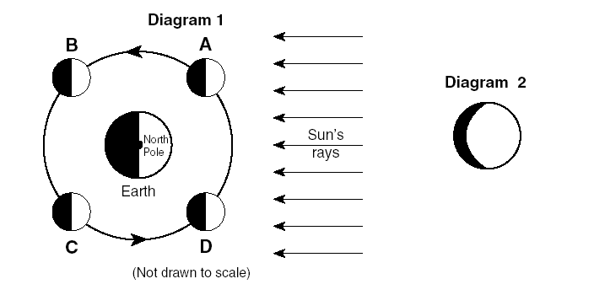
22. At which labeled Moon position would the
phase of the Moon shown in diagram 2 be
observed from New York State?
(1) A (3) C
(2) B (4) D

23. What is the name of the phase shown in
diagram 2?

_________________________________

Base your answers to questions 24 and 25 on the graph below, which shows two days of tidal data from a coastal location in the northeastern United States.
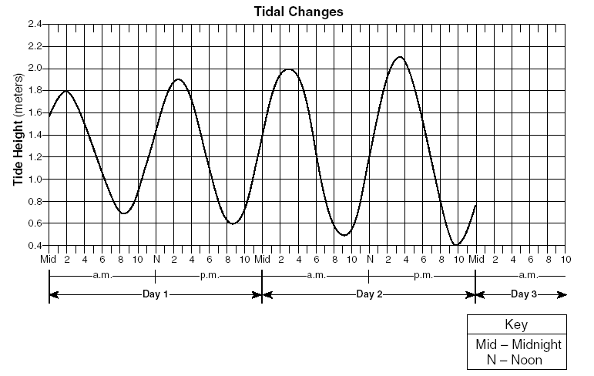

24 The change in the tides as shown on the graph is primarily the result of
(1) Earth’s rotation and the Moon’s revolution
(2) Earth’s rotation and revolution
(3) the Moon’s rotation and Earth’s revolution
(4) the Moon’s rotation and revolution

25. If the pattern shown continues, the most likely height and time for the first high tide on day 3 would be
(1) 2.2 meters at 4 a.m. (3) 2.2 meters at 5 a.m.
(2) 2.3 meters at 4 a.m. (4) 2.3 meters at 5 a.m.

26. The diagram below represents the Sun’ Sun’s rays striking Earth and the Moon.
Numbers 1 through 4 represent positions of the Moon in its orbit around Earth.
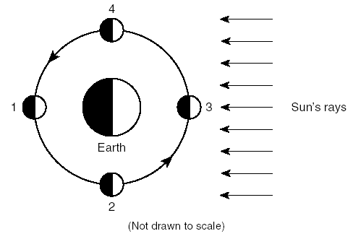
Which position and phase of the Moon would result in a solar eclipse?
- position 1, the full Moon
- position 3, the full Moon
- position 1, the new Moon
- position 3, the new Moon

Base your answers to questions 27 through 29 on the diagram below, which has lettered arrows showing the motions of
Earth and the Moon.
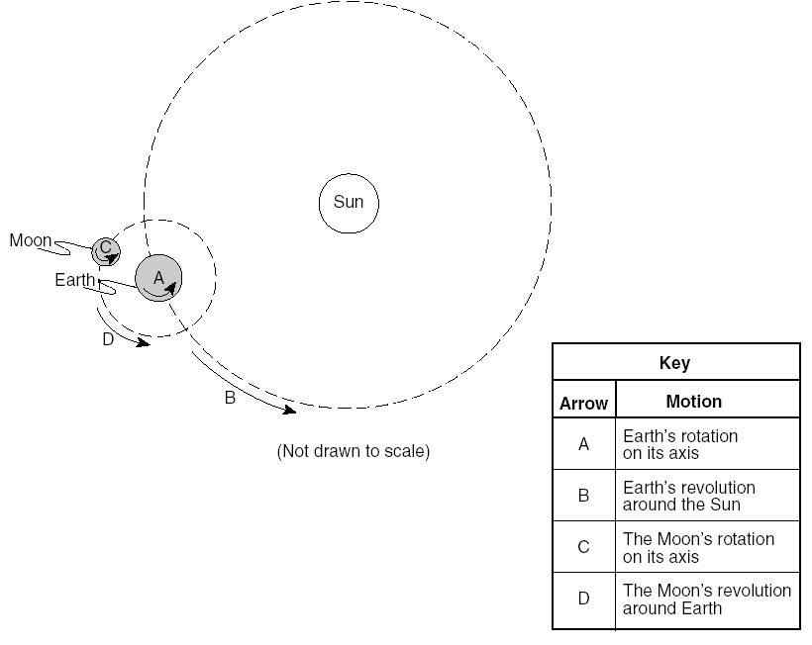

27. These lettered arrows represent motions that are
(1) noncyclic and unpredictable
(2) noncyclic and predictable
(3) cyclic and unpredictable
(4) cyclic and predictable

28. Which two motions are completed in about the same amount of time?
(1) A and B (3) C and D
(2) B and C (4) A and D

29. Which lettered arrow represents the motion that causes the Moon to show phases when viewed from Earth?
(1) A (3) C
(2) B (4) D

30. The Moon's gravitational force has a greater tide causing effect on bodies of water
on the Earth than the Sun's gravitational force. What is one reason for this?
(1) The Moon's mass is greater than the Sun's mass.
(2) The Moon is closer to the Earth than the Sun is.
(3) The Moon's mass is less than the Sun's mass.
(4) The Moon's gravitational force always attracts while the Sun's sometimes repels.

31. How long is one full cycle of Moon phases? ________________

32. How long is one complete Moon revolution? ________________

