Topic IV
Part 2
Earth Motions

Topic: Earth Motions
Aim:

1.

2.

3.
side view top view
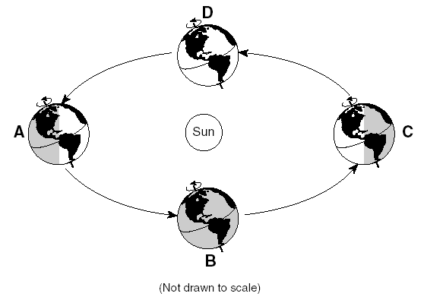
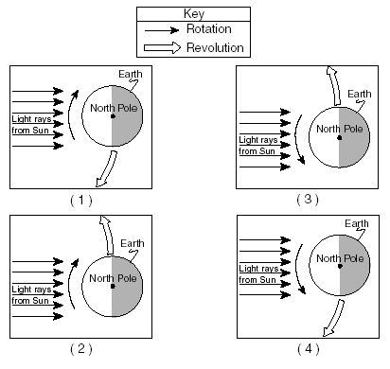

4.

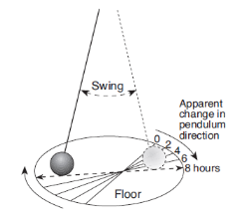
5.

6.
Earth Science
Reference Tables
Page 4
Surface Ocean Currents
Page 14
Planetary Wind and
Moisture Belts

Topic: Earth Motions
Aim:

CIRCUMPOLAR STAR TRAILS:

As a result of Earth’s rotation, stars appear to make daily, circular paths around Polaris.

Stars appear to move counterclockwise at a rate of 15º/hr.

1.
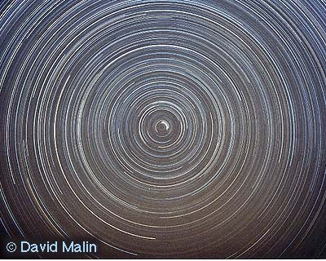

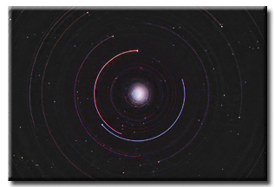
2.

Topic: Earth Motions
Aim:

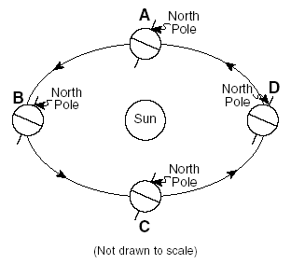
1.

2.

3.

4.

5.

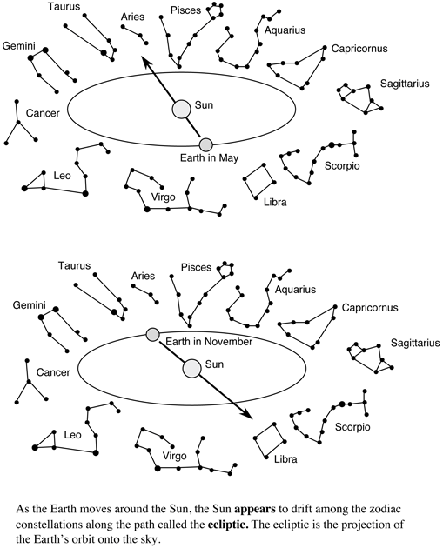
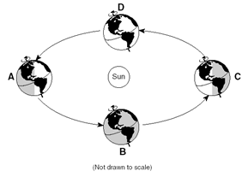
winter
summer
autumn
spring

Rotation and Revolution

1. The time required for one Earth rotation is about
- one hour (3) one month
- one day (4) one year

- The planet Jupiter was viewed from Earth for several hours. The diagrams below represent the appearance of Jupiter at four different times.

The best inference that can be made based on the diagrams is that this planet is
- tilted on its axis (3) revolving
- changing seasons (4) rotating

- The Earth rotates on its axis at a rate of approximately
- 1 degree per hour (3) 23½ degrees per hours
- 15 degrees per hour (4) 360 degrees per hour

- If the Earth’s rate of rotation decreased, there would be an increase in
- length of the seasons (3) Sun’s angle of insolation at noon
- number of observable stars at night (4) length of time for one Earth day

- Why do stars appear to move through the night sky at the rate of 15º per hour?
- The Earth actually moves around the Sun at a rate of 15º per hour.
- The stars actually move around the center of the galaxy at a rate of 15º per hour.
- The Earth actually rotates at a rate of 15º per hour.
- The stars actually revolve around the Earth at a rate of 15º per hour.

- Which statement best explains the apparent daily motion of the Sun and other stars?
- The Earth’s orbit is an ellipse.
- The Earth has a shape of an oblate spheroid.
- The Earth rotates on its axis.
- The Earth revolves around the Sun.

- Which is the best evidence for the Earth’s rotation?
- the rising of the Sun (3) the changing of the seasons
- the phases of the Moon (4) the motion of a Foucault pendulum

- In its orbit around the Sun, approximately how many degrees per day does the Earth revolve?
(1) 1º (3) 15º
(2) 365º (4) 90º

- The diagram illustrates the orbital motion of the Earth.

The orbital motion is one of the factors that cause
- the Coriolis Effect
- sunrise and sunset
(3) the changing seasons
(4) circumpolar star trails

- What is the total number of degrees that the Earth rotates on its axis during a 10-hour period?
(1) 1º (3) 150º
(2) 15º (4) 180º

- Some stars that can be seen in New York State on a summer night cannot be seen on a winter night.
This fact is a result of the
- rotation of the Earth on its axis (3) rotation of the stars around Polaris
- revolution of Polaris around the Earth (4) revolution of the Earth around the Sun

- Evidence that the Earth rotates on its axis is provided by Foucault’s pendulum and the
- Coriolis Effect (3) phases of the moon
- position of the Sun at solar noon (4) geocentric model of the solar system

- Which real motion causes the Sun to appear to rise in the east and set in the west?
- the Sun’s revolution (3) the Earth’s revolution
- the Sun’s rotation (4) the Earth’s rotation

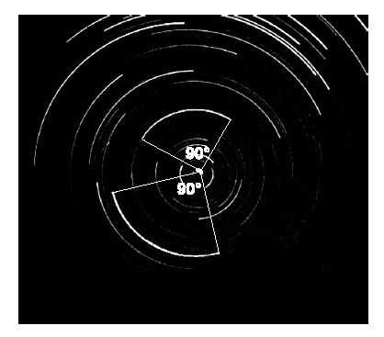
14. A camera was placed in an open field and pointed toward the
northern sky. The lens of the camera was left open for a certain
amount of time. The result is shown in the photograph below.
The angle of the arc through which two of the stars appeared to
move during this time exposure is shown.

How many hours was the lens left open to produce
the photograph?
(1) 12 (3) 6
(2) 2 (4) 4

15. A rocket is fired from the North Pole directly south. To an observer on the Earth's surface,
the rocket's path appears to curve to the right of its intended target. This is evidence that
(1) the gravitational attraction varies over the surface of the Earth
(2) the Earth rotates on its axis
(3) the Earth orbits around the Sun in an elliptical path
(4) differences in air pressure exist between the North Pole and point A.

Base your answers to question 16 on the diagram below, which represents Earth in its orbit
around the Sun. The position of Earth on the first day of each season is labeled A, B, C, and D.
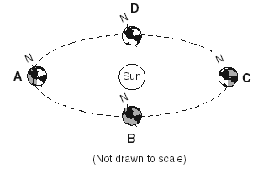

16. Which diagram correctly shows the directions of Earth’s revolution and rotation?
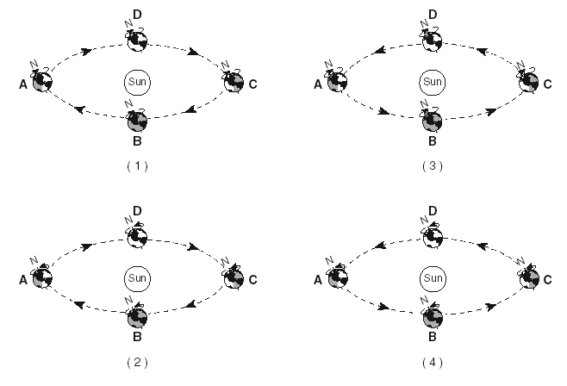

17. Which event is caused by Earth’s revolution?
(1) the apparent shift in the path of a Foucault pendulum
(2) deflection of planetary winds to the right in the Northern Hemisphere
(3) the apparent rising and setting of the Sun
(4) different constellations observed in the night sky throughout the year
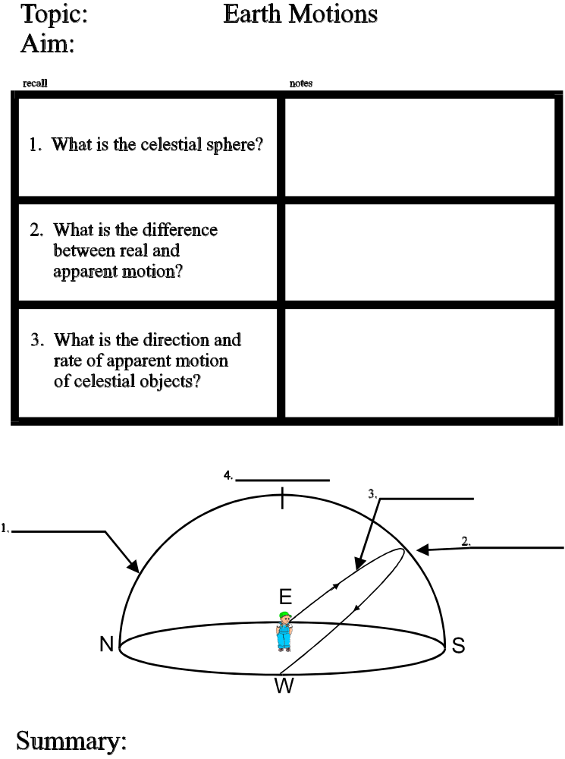

The celestial sphere is the imaginary dome of the sky onto which all celestial objects (stars, planets, moons, galaxies, constellations) can be plotted.

Real Motion – how a celestial object actually moves.

Apparent Motion – how a celestial object
seems to move.

Celestial objects appear to rise in the east,
move across the sky at a rate of 15º/hour,
and appear to set in the west.

This apparent motion is caused by the Earth’s
real motion: rotation from west to east.



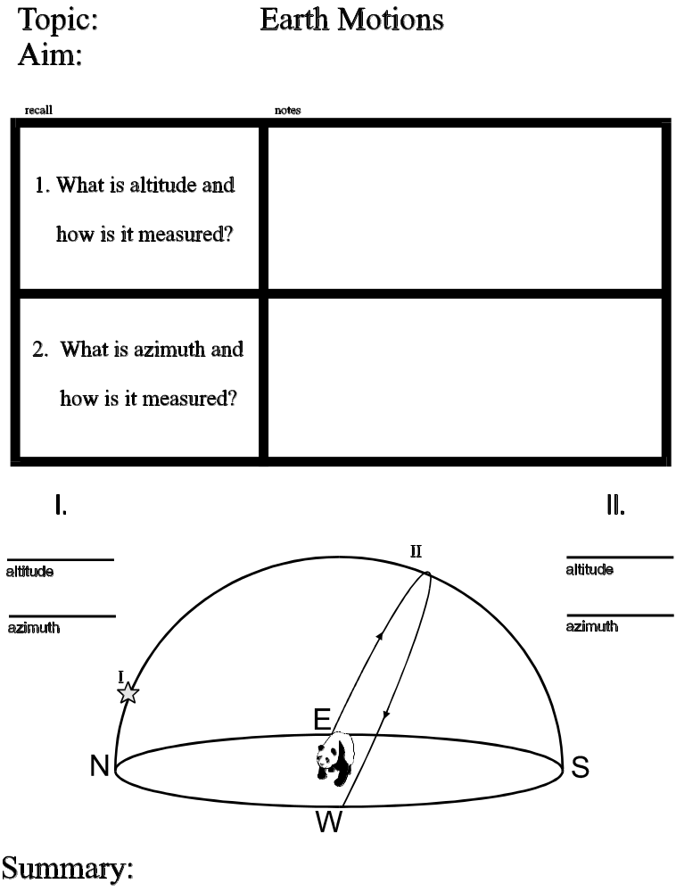

The height of a celestial object above the horizon measured in degrees

0º → lowest (object on horizon)
90º → highest (object at observer’s zenith)

a.
b.
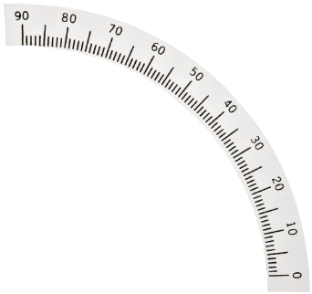

a

b

S

Altitude, Azimuth, and Apparent Motion of Celestial Objects

1. The constellation Pisces changes position during a night, as shown in the diagram below.
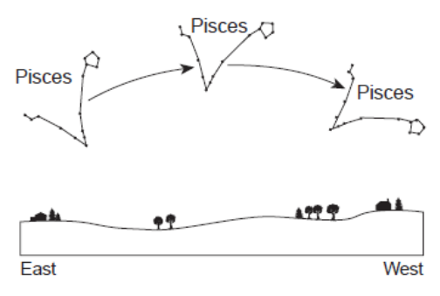
Which motion is mainly responsible for this
change in position?
(1) revolution of Earth around the Sun
(2) rotation of Earth on its axis
(3) revolution of Pisces around the Sun
(4) rotation of Pisces on its axis

2. Because the Earth rotates, the Sun and other stars appear to
(1) rise in the east and set in the west
(2) rise in the west and set in the east
(3) rise in the south and set in the north
(4) rise in the north and set in the south

3. A person in New York State observes a star that is due east and just above the horizon. During the next
hour, the distance between the star and the horizon will appear to
(1) decrease (2) increase (3) remain the same

Use the diagram to the right to answer questions 4-7.

4. For which path is the altitude of the noon Sun 74 °?
(1) A-A' (3) C-C’
(2) B-B' (4) D-D'

5. How many degrees does the altitude of the Sun
change from December 21 to June 21?
(1) 43° (3) 66 ½°
(2) 47° (4) 74°

6. Which statement best explains the apparent daily
motion of the Sun?
(1) The Earth's orbit is an ellipse.
(2) The Earth's shape is an oblate spheroid.
(3) The Earth is closest to the Sun in winter.
(4) The Earth rotates on its axis.

7. What is the azimuth of sunrise on December 21st?
(1) east (3) southeast
(2) northeast (4) southwest



1.

2.

1. If it is noon in New York, toward which direction would an observer look to see a shadow?
(1) north (3) west
(2) south (4) east

- As the altitude of the Sun increases, the length of the shadow cast by a vertical pole will
(1) decrease (2) increase (3) remain the same

3. When observed from sunrise to sunset in New York State, the length of a shadow cast by a vertical pole will
(1) increase, only (3) first decrease, then increase
(2) decrease, only (4) first increase, then decrease

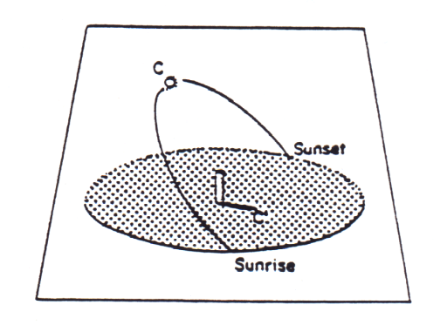
4. The diagram to the right shows the Sun’s maximum
altitude (C) relative to a vertical stick in New York State
on June 21. In which direction from the base of the
stick does shadow C’ point?

- north
- south
- east
- west

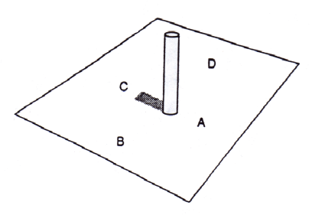

5. A vertical post was observed in New York State at exactly 12 noon.
Which letter indicates a location south of the post?
(1) A (2) B (3) C (4) D

Celestial Sphere Observations Practice

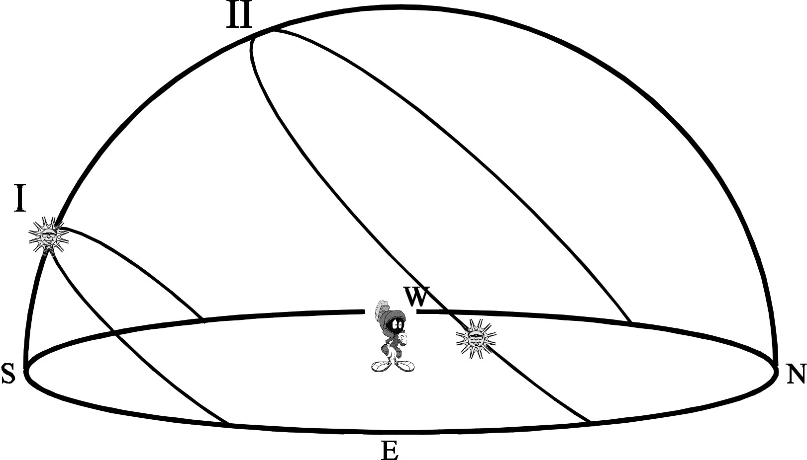

N

1. What is the approximate altitude of the Sun on path I? ______________

2. What is the azimuth of the Sun on path I? ______________

3. What is the approximate time of day when the Sun is at its position on path I? ______________

4. What direction would the Sun rise on the date represented by path I? ______________

5. What is the azimuth of the Sun on path II? ______________

6. What is the approximate time of day when the Sun is at its position on path II? ______________

7. What direction would Marvin’s shadow point when the Sun is at ______________
its highest point on arc path I?

8. Which would give Marvin a longer shadow: the noon Sun on path I or the noon Sun on path II?
Explain your answer.
____________________________________________________________________________________________

____________________________________________________________________________________________

9. If this diagram represents observations made from NYC, plot the approximate location of Polaris on the celestial sphere.

B

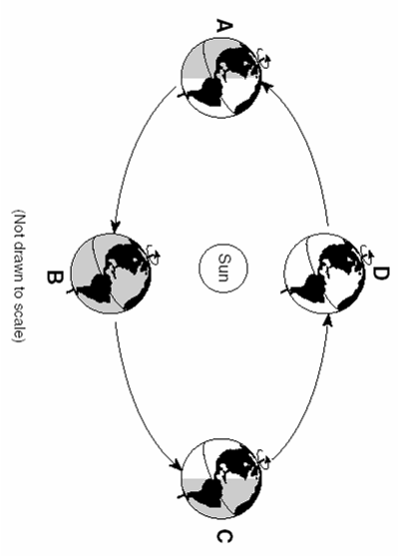

Diagram Not to Scale

A
C
D

Seasons are caused by:

1. _________________________________________

2. _________________________________________

3. _________________________________________

_________________________________________

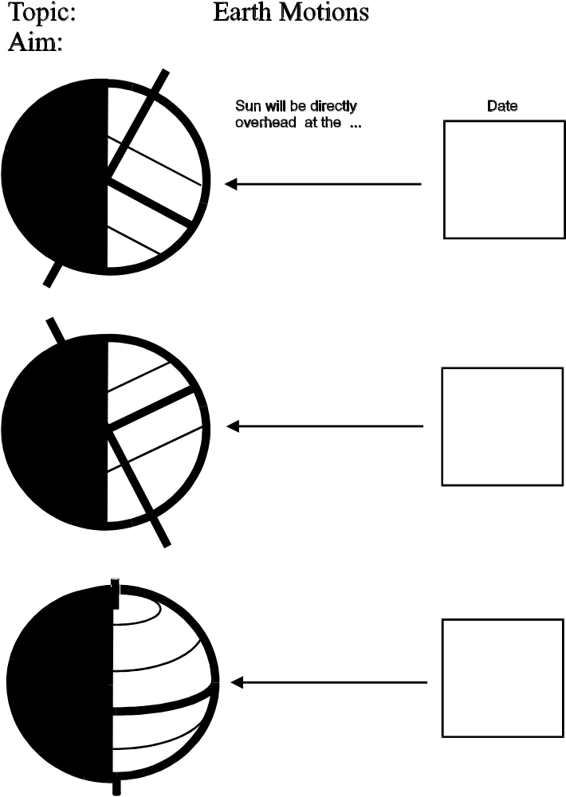

Tilt of the Earth and the Seasons

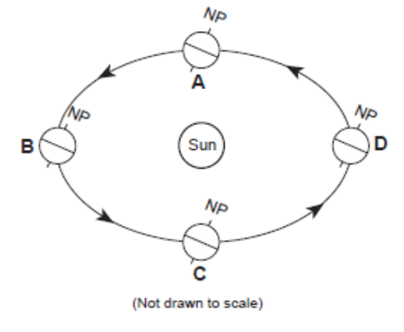
- Which position in the diagram to the right
best represents the Earth on the first day
of summer in the Northern Hemisphere?

- A
- B
- C
- D

- The tilt of the Earth on its axis is a cause of the Earth’s
- uniform daylight hours
- seasons
- 24-hour day
- 365¼ day year

- In the diagram to the right, the direct rays of the
Sun’s rays are striking the Earth’s surface at 23½ºN.

What is the date shown in the diagram?
- March 21
- June 21
- September 23
- December 21

- The factor that contributes most to the seasonal temperature changes during one year in New York State is the changing
- speed at which the Earth travels in its orbit around the Sun
- tilt of Earth’s axis
- distance between the Earth and Sun
- energy given off by the Sun

- 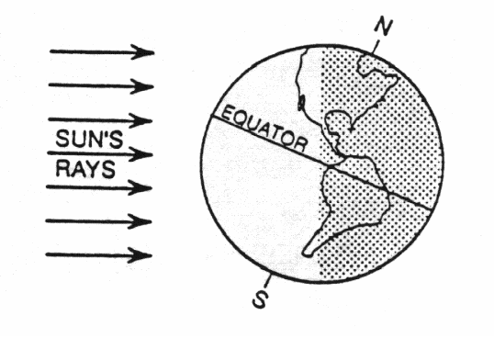The diagram to the right represents the Earth in space.

Which date is most likely represented by the diagram?

- June 6
- September 2
- December 30
- May 4

- In the Northern Hemisphere, during which season does the Earth reach its greatest distance from the Sun?
(1) winter (3) spring
(2) summer (4) fall

7. On June 21st the Sun will be directly overhead at the
1 Tropic of Cancer 3 Equator
2 Tropic of Capricorn 4 North Pole

Questions 8-9:
The diagram below represents four positions of the Earth as it revolves around the Sun.

8. At which position is the Earth located on December 21?
- A (3) C
- B (4) D

9. Which position of the Earth represents the vernal (spring) equinox?
(1) A (3) C
(2) B (4) D

10. The Earth’s axis of rotation is tilted 23½ degrees from a line perpendicular to the plane of its orbit.
What would be a result if the tilt were increased to 33 ½ degrees?
- an increase in the amount of solar radiation received by the Earth
- colder winters and warmer summers in New York State
- less difference between winter and summer temperatures in New York State
(4) shorter days and longer nights at the Equator

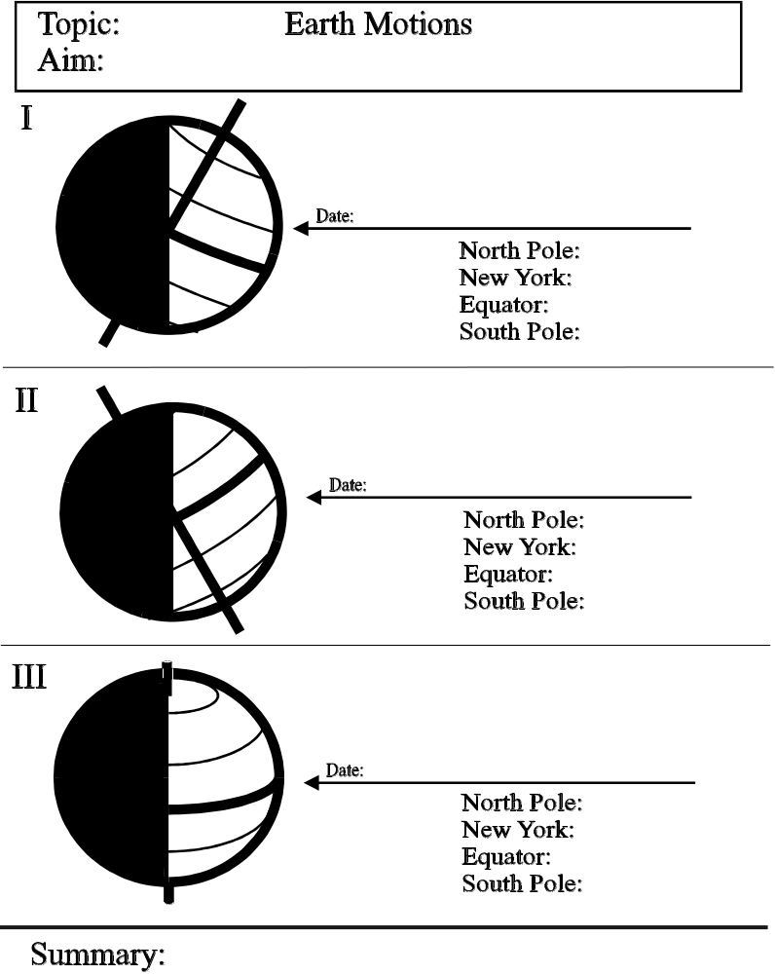

A major seasonal change resulting from Earth’s tilt is that different latitudes will receive different amounts of daylight hours.

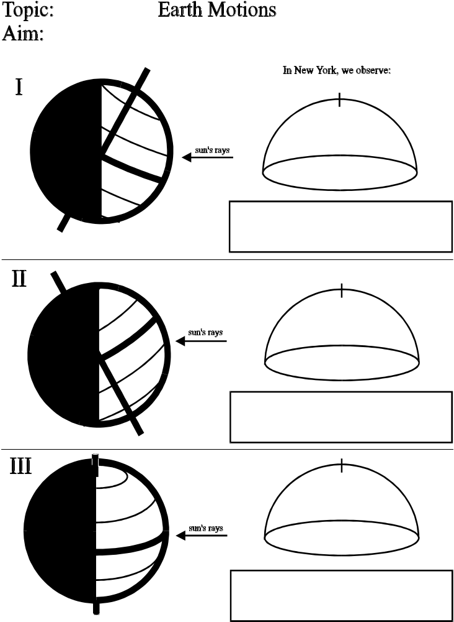

E

N
S
W

E

N
S

W

E

N
S
W

** Because of the Earth’s tilt, the altitude of the noon Sun changes 23 1/2º at the start of each consecutive season. **

Daylight Hours

- Which two factors determine the number of hours of daylight at a particular location?
  - longitude and season (3) longitude and the Earth’s average diameter
  - latitude and season (4) latitude and the Earth’s average diameter

- New York State has several more hours of daylight in summer than in winter.
Which statement helps explain the observation?
  - The Earth is tilted on its axis.
  - The distance between the Earth and the Sun varies.
  - The diameter of the Sun appears to change.
  - The speed of the Earth in its orbit changes.

- In New York State, between February and May, the number of daylight hours
  - decreases (2) increases (3) remains the same

- Which graph best represents the relationship between latitude north of the Equator and the length of daylight period on March 21?
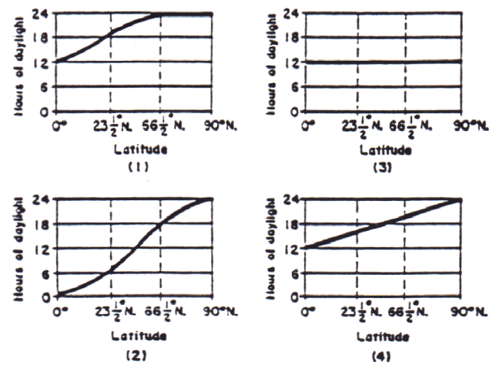

- In New York State, the number of hours of daylight each day increases continuously from
  - March 1 to May 1 (3) September 1 to November 1
  - June 1 to August 1 (4) December 1 to February 1

6. The total number of hours of daylight
received by the position A on the date
represented in the diagram is closest to
1 0 hr 3 18 hr
2 12 hr 4 24 hr

Topic: Earth Motions
Aim:

Remember: No matter where an on Earth an observer is located, the apparent path of the Sun for each special date
will be parallel to each other and, once again, changes 23 1/2º at the start of each consecutive season.

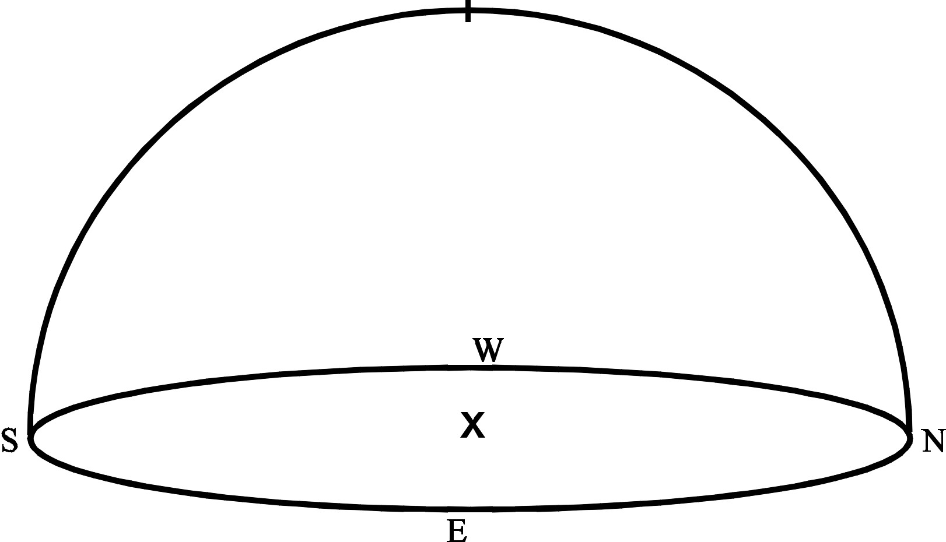

1. Location:

2. Location:

3. Location:

EARTH MOTIONS EXAM REVIEW

Base your answers to questions 1 and 2 on the diagram below, which shows a model of Earth’s orbit around the Sun. Letters A, B, C, and D represent Earth’s position at the beginning of each season.

1. Which of the following statements is true of the diagram?
(1) Position A is summer in the Northern Hemisphere and the Earth is at perihelion.
(2) Position C is winter in the Northern Hemisphere and the Earth is at aphelion
(3) Position C is summer in the Northern Hemisphere and the Earth is at aphelion.
(4) Position D is winter in the Northern Hemisphere and the Earth is at perihelion.

2. The diagram below shows how Earth is illuminated [lighted] by the Sun as viewed from above the North Pole.
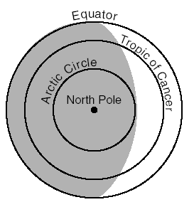

In which orbital position would Earth be lit up as shown?
(1) A (3) C
(2) B (4) D

3. Which motion causes the constellation Orion to be visible at midnight from New York State in
winter but not in summer?
(1) rotation of Earth (3) revolution of Orion
(2) rotation of Orion (4) revolution of Earth

4. Approximately how many hours of daylight does New York experience on the summer solstice?
(1) 9 (2) 12 (3) 15 (4) 18

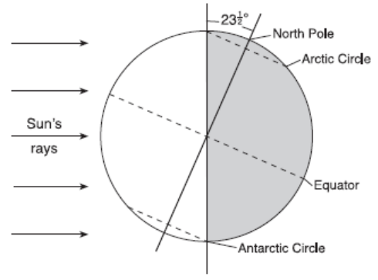
5. The diagram to the right shows Earth on a particular
day in its orbit around the Sun. The dashed line
represents Earth’s axis.

Which date is represented by the diagram?
(1) March 21
(2) June 21
(3) September 23
(4) December 21

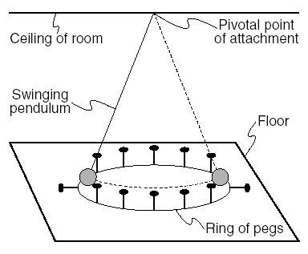
6. The diagram represents a swinging
Foucault pendulum.

This pendulum will show an apparent change
In the direction of its swing due to Earth’s
(1) curved surface
(2) tilted axis
(3) rotation
(4) revolution

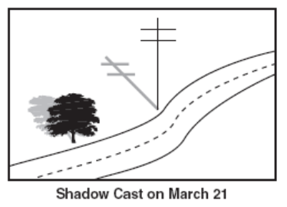
7. The diagram shows the shadow cast by a telephone pole on
March 21 at solar noon at a location in New York State.
Which shadow was cast by the same telephone
pole on June 21 at solar noon?
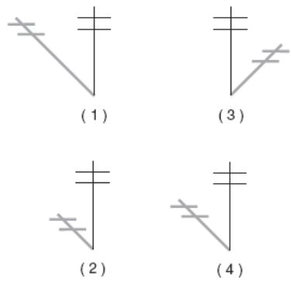

8. Earth’s rate of revolution is approximately
(1) 1° per day (3) 15° per day
(2) 15° per hour (4) 1° per hour

9. The Coriolis effect provides evidence that the
(1) Earth rotates on its axis (3) Sun rotates on its axis
(2) Earth revolves around the Sun (4) Sun revolves around the Earth

10. In New York State, the number of hours of daylight each day decreases continuously from
(1) March 1 to May 1 (3) August 1 to October 1
- June 1 to August 1 (4) December 1 to February 1

11. If Earth’s axis were tilted less than 23.5°, which seasonal average temperature change would
occur in New York State?
(1) Spring and fall would be cooler. (3) Winter would be cooler.
(2) Spring and fall would be warmer. (4) Summer would be cooler.

12. Seasonal changes on Earth are primarily caused by the
(1) parallelism of the Sun’s axis as the Sun revolves around Earth
(2) changes in distance between Earth and the Sun
(3) elliptical shape of Earth’s orbit around the Sun
(4) tilt of Earth’s axis as Earth revolves around the Sun

13. As viewed from Earth, most stars appear to move across the sky each night because
(1) Earth revolves around the Sun (3) stars orbit around Earth
(2) Earth rotates on its axis (4) stars revolve around the center of the galaxy
14. Which diagram represents the approximate location of the Sun at 3 p.m. on March 21?
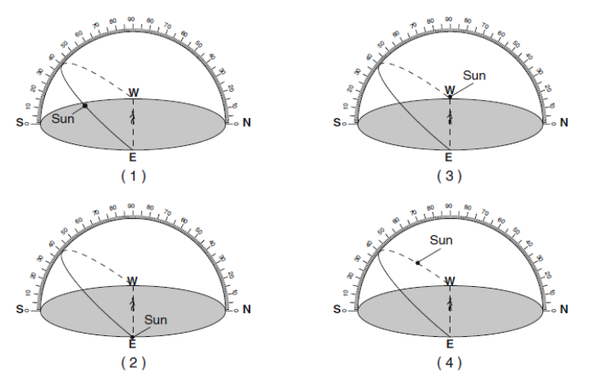

15. To a nighttime observer in New York state facing north, a three hour observation of stars would show a
(1) 15º apparent motion, clockwise around Polaris
(2) 15º apparent motion, counterclockwise around Polaris
(3) 45º apparent motion, counterclockwise around Polaris
(4) 45º apparent motion, clockwise around Polaris

16. Which diagram represents the apparent path of the Sun on an Equinox for an observer at the Equator?
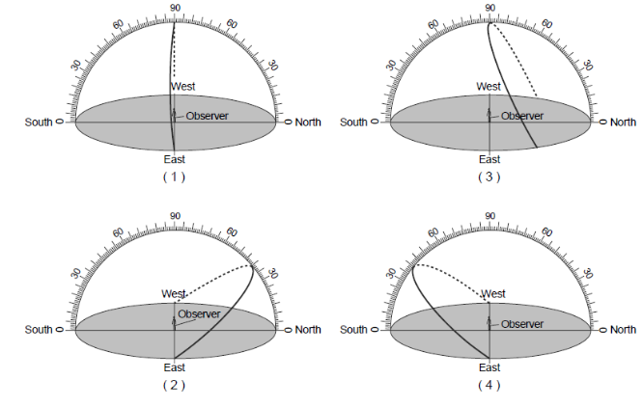

Base your answers to questions 17-21 on the diagram below and your knowledge of earth science. The diagram represents a plastic hemisphere upon which lines have been drawn to show the apparent paths of the Sun at one location in New York State on the first day of each season. Letters A through I represent points on the paths.

17. As the Sun moves across its path from position D to A to G, shadow lengths created by the Sun will
(1) decrease, only (3) decrease, then increase
(2) increase, only (4) increase, then decrease
18. Which point represents sunrise on the first day of the winter season?
(1) A (3) F
(2) G (4) D

19. What is the total number of hours needed for the Sun to follow path EBH?
(1) 8 hr (3) 12 hr
(2) 10 hr (4) 16 hr

20. What is most likely the altitude of point A?
(1) 25° (3) 60°
(2) 45° (4) 72°

21. Which position represents sunset in the summer?
(1) I (3) E
(2) G (4) H

22. Which factor has the greatest influence on the number of daylight hours that a particular Earth
surface location receives?
(1) longitude (3) diameter of Earth
(2) latitude (4) distance from the Sun

Base your answers to questions 23-28 on the diagram below, which represents a model of the sky (celestial sphere) for an observer in New York State. The curved arrow represents the Sun’s apparent path for part of one day. The altitude of Polaris is also indicated.

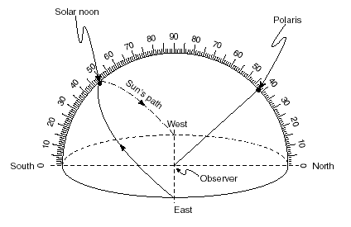

y

x

23. According to this diagram, what is the Sun’s altitude at solar noon?
(1) 23.5° (2) 42° (3) 48° (4) 90°

24. What time of day would it be if the Sun was located at position y?
(1) 6:00 am (2) 8:00 am (3) 11:00 am (4) 2:00 pm

25. On which date could this observation of the Sun’s apparent path have been made?
(1) October 21 (3) September 23
(2) July 21 (4) December 21

26. What is the azimuth of the Sun when it is located at position y?
(1) west (3) northwest
(2) southwest (4) northeast

27. When the Sun is located at position x, the observer’s shadow will point toward the
(1) west (3) northwest
(2) northeast (4) southeast
28. The azimuth of Polaris is
(1) north (3) northwest
(2) northeast (4) east

Use the diagram below to answer questions 29-31.

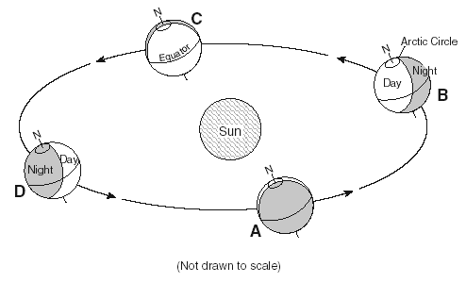
The diagram below shows Earth’s orbit around the Sun. Locations A, B, C, and D represent Earth on
the first day of each season.

29. Which location represents September 23?
(1) A (3) C
(2) B (4) D

30. How many hours of daylight would be experienced at the North Pole at position D?
(1) 0 (3) 18
(2) 12 (4) 24

31. Which latitude would be receiving the direct ray of the Sun when the Earth is at position B?
(1) Equator (3) Tropic of Cancer
(2) Arctic Circle (4) Tropic of Capricorn

32. Winter in New York State is colder than summer because in the winter, New York State has
(1) fewer hours of daylight and is farther from the Sun
(2) more hours of daylight North Polar tilt is toward the Sun
(3) more hours of daylight and is farther from the Sun
(4) fewer hours of daylight and the North Polar tilt is away from the Sun

33. Which diagram correctly shows the
direction of Earth’s rotation and revolution?

