Topic II
The Model
of the Earth

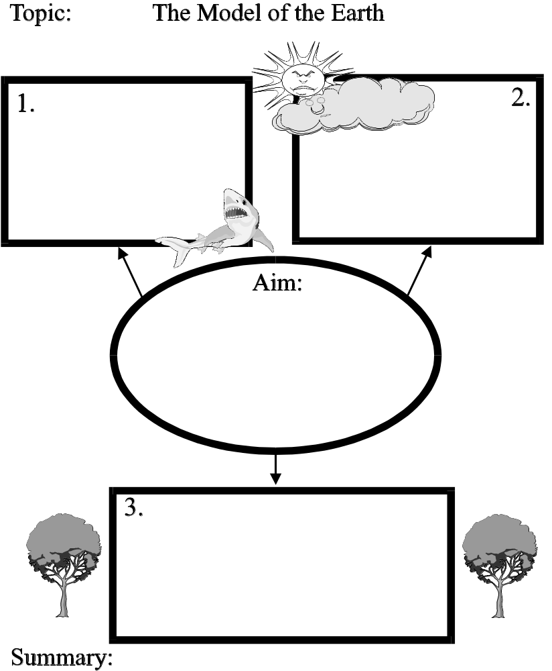
Date ____________

- liquid water part of the Earth
- covers 70% of the Earth
- average depth 3.5 km

- shell of gases surrounding Earth (layered)
- average depth = 600 km

Atmosphere
Hydrosphere
Lithosphere

- solid outer part of the Earth
- thickness = 75-150 km

Aim:

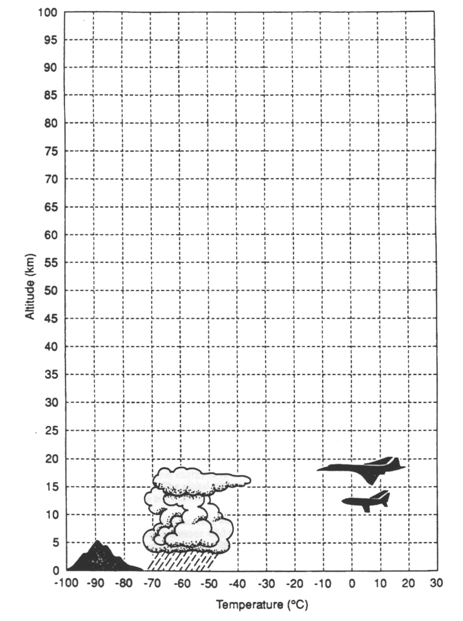
KEY

Date ____________
The Parts of the Earth

1. The lithosphere is the
1 solid outer part of the Earth 3 gaseous part of the Earth
2 liquid part of the Earth 4 solid and liquid parts of the Earth

2. Which statement most accurately describes the Earth’s atmosphere?
- The atmosphere is layered, with each layer possessing distinct characteristics.
- The atmosphere is the gas that surrounds some of the Earth.
- The atmosphere’s altitude is less than the depth of the ocean.
- The atmosphere is more dense than the hydrosphere but less dense than the lithosphere.

3. Which two elements listed below are most abundant by mass in the Earth’s crust?
- silicon and oxygen 3 oxygen and magnesium
- hydrogen and iron 4 hydrogen and calcium

4. Which line best identifies the boundary between the lithosphere and the troposphere?
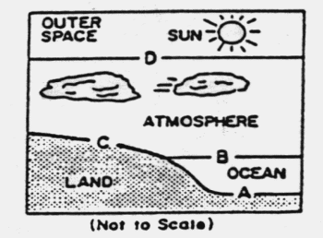
- line A
- line B
- line C
- line D

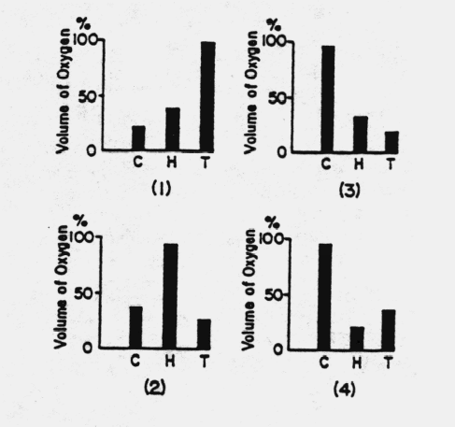

5. According to the Earth Science Reference Tables,
which graph best represents the percent of oxygen,
by volume, found in the Earth’s crust (C),
hydrosphere (H), and troposphere (T)?

6. In which group are the spheres of the Earth listed in order of increasing density?
(Remember … you know what each of these are made up of …)
- atmosphere, hydrosphere, lithosphere
- hydrosphere, lithosphere, atmosphere
- lithosphere, hydrosphere, atmosphere
- lithosphere, atmosphere, hydrosphere

7. Ozone gas in the Earth’s atmosphere helps to protect life on the Earth. This protection is due to
the ability of ozone to absorb
1 radio waves 3 gamma radiation
2 ultraviolet radiation 4 visible radiation

Base your answers to questions 8-12 on the Earth Science Reference Tables, the information and the chart below, and your knowledge of Earth Science. The data were recorded by weather instruments carried into the atmosphere by a gas-filled balloon.
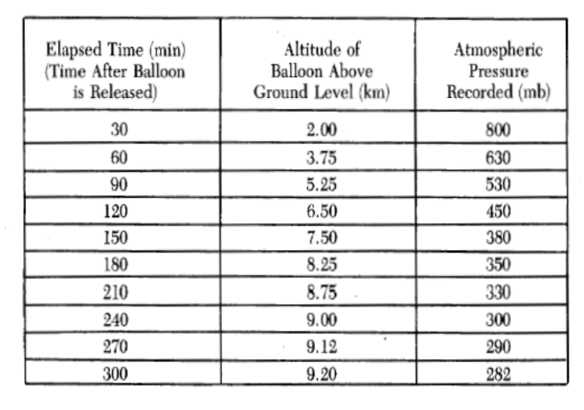
8. As the altitude of the balloon increased,
the air pressure
1 increased, only
2 decreased, only
3 remained the same
4 increased and then decreased

9. What kind of relationship exists between altitude
and air pressure?
1 direct
2 inverse
3 cyclical
4 unaffected

10. Which graph best represents the relationship between elapsed time and the altitude of the balloon?
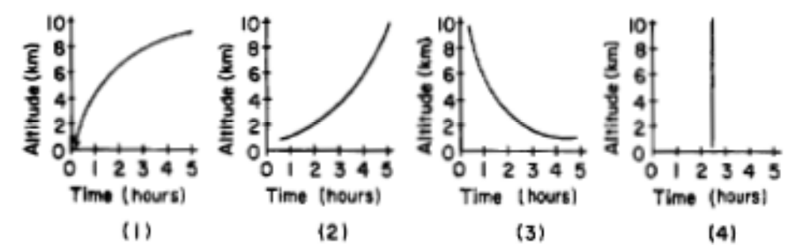

11. What is the most abundant element in the atmosphere surrounding this balloon?
1 hydrogen 3 carbon dioxide
2 nitrogen 4 oxygen

12. How did the water vapor content and the air temperature change as the balloon’s altitude increased?
(Use the Earth Science Reference Tables)
1 water vapor content and air temperature both decreased
2 water vapor content and air temperature both increased
3 water vapor content increased and air temperature decreased
4 water vapor content decreased and air temperature increased

13. The element oxygen is found in the Earth’s
1 troposphere, only
2 hydrosphere, only
3 troposphere and hydrosphere, only
4 troposphere, hydrosphere, and crust

14. Which substance released by humans into the atmosphere has contributed to ozone depletion?
1 carbon dioxide 3 sulfur
2 chlorofluorocarbons 4 carbon monoxide

15. In which group are the layers of the Earth’s atmosphere listed in order of increasing thickness?
- troposphere, mesosphere, stratosphere, thermosphere
- troposphere, stratosphere, mesosphere, thermosphere
- thermosphere, mesosphere, stratosphere, troposphere
- troposphere, thermosphere, stratosphere, mesosphere

16. 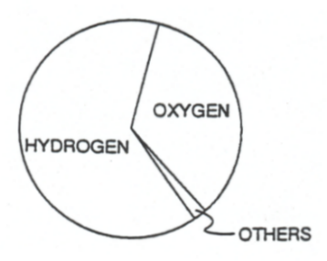The graph to the right represents the percentage of elements by volume.

This graph best represents the elements of the Earth’s
- lithosphere
- hydrosphere
- troposphere
- stratosphere

17. What is the approximate temperature at the tropopause?
1 0ºC
2 55ºC
3 15ºC
4 -55ºC

18. As the altitude in the stratosphere increases, the air temperature in the stratosphere
1 increases
2 decreases
3 remains the same

19. The ozone layer is located in the
1 troposphere 3 hydrosphere
2 stratosphere 4 thermosphere

20. The solid rock material that directly underlies sediments on the ocean floor is part of the Earth’s
1 lithosphere 3 troposphere
2 hydrosphere 4 outer core

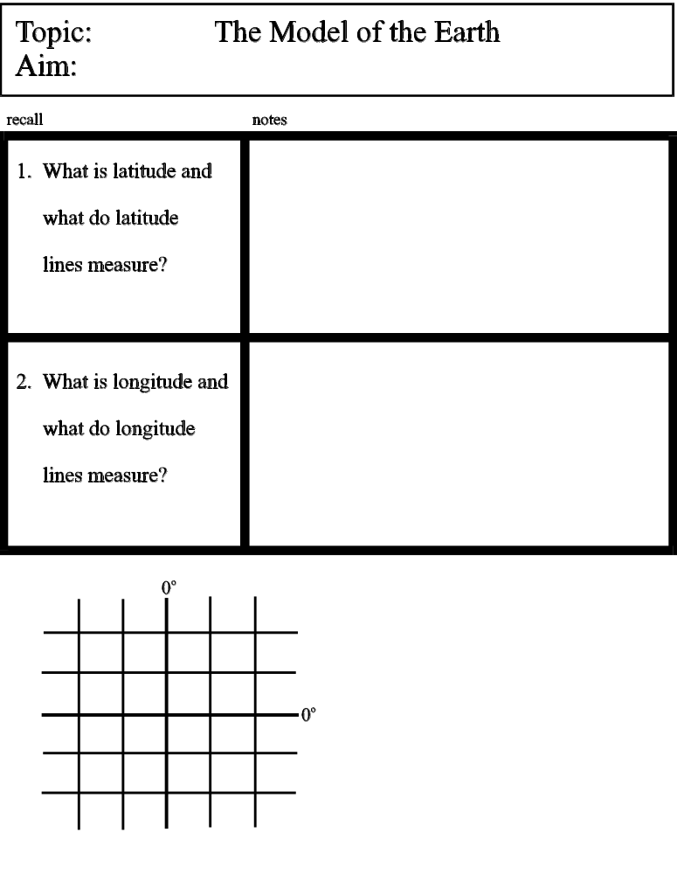
Date ____________

a. latitude lines are horizontal lines (remember:” lat – flat”)
(parallel lines)
b. measure how far a location is
north or south of the Equator.
c. ranges from 0º to 90º

a. longitude lines are vertical lines
(intersect at the poles)
b. measure how far a location is west or east of
the Prime Meridian (Greenwich Meridian).
c. ranges from 0º to 180º

Location | Latitude | Longitude
W

X

Y

Z

Date ____________

Latitude and Longitude Review Worksheet

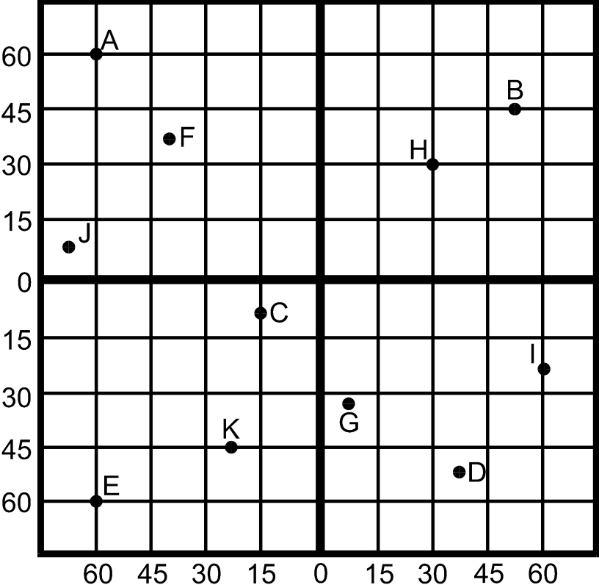

- Complete the chart below by finding the coordinates of each point.

Location | Latitude | Longitude

A
B
C
D

2. Which point is located at 45ºS and 23ºW? _______________

3. Which point is located at 32ºS and 7ºE? _______________

4. Which two points have the same longitude? _______________

- What is the difference in longitude _______________
between points H and I?

- What is the difference in longitude _______________
between points H and C?
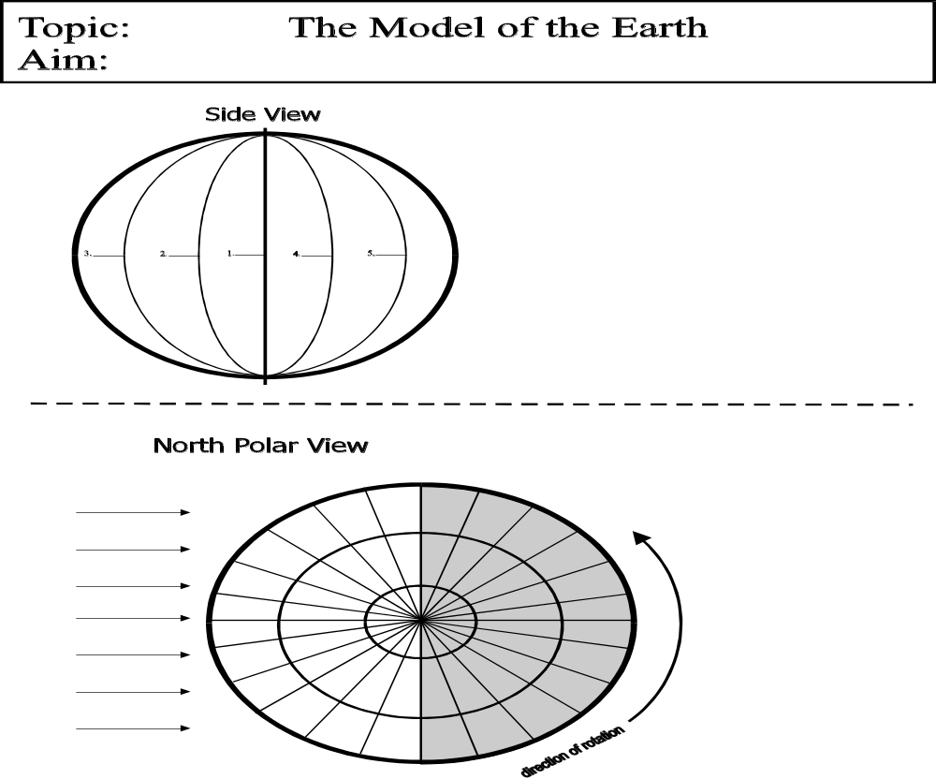
Date ____________

Degrees / Minutes System of Latitude and Longitude: **Mainly used on ESRT page 3**

a degree of latitude or longitude can be divided into subunits called minutes
1º = 60’ “tick mark” is the symbol for minutes
½º = 30’

LATITUDE
LONGITUDE
42ºN
(42º00’N)
43ºN
(43º00’N)
44ºN
(44º00’N)
43½ºN
(43º30’N)
42½ºN
(42º30’N)
75ºW
(75º00’W)
76ºW
(76º00’W)
77ºW
(77º00’W)
76½ºW
76º30’W)
75½ºW
(75º30’W)
:

Date ____________
Latitude and Longitude Review Worksheet
Use the Earth Science Reference Tables to determine the coordinates of the listed locations.
1. What is the latitude and longitude of New York City?
(to the nearest whole degree) ________________________

For questions 2-6:
Use page 3 of the ESRT to approximate the latitudes and longitudes of locations in NYS on to the nearest minute.

2. What is the latitude and longitude of Slide Mountain, NY? ________________________

3. What is the latitude and longitude of Albany, NY? ________________________

4. What is the latitude and longitude of Ithaca, NY? ________________________

5. What is the latitude and longitude of Jamestown, NY? ________________________

6. What is the latitude and longitude of Mt. Marcy, NY? ________________________

7. At approximately which latitude would one experience the ________________________
Equatorial Countercurrent in the Pacific Ocean?
(Check out ESRT page 4 ...)

Use the Tectonic Plates map on page 5 of the Earth Science Reference Tables, what is the approximate
latitude and longitude (to the nearest whole degree) of the following mantle hot spots (estimate the values
from the center of the hot spot symbol on the map):

8. Hawaii Hot Spot __________________________________

9. Iceland Hot Spot __________________________________

10. Yellowstone Hot Spot __________________________________

11. Canary Islands Hot Spot __________________________________

Date ____________

SIDE VIEW

Notes

- longitude lines intersect at poles

- from side view you can’t see every longitude line / time zone

Prime Meridian (0º) =
Greenwich Meridian

180º = International Date Line
(opposite side of 0º)

On a globe:

Each line of longitude is 15º apart or 1 hour apart

When working with time zones remember:
Left is less!

NORTH POLAR VIEW
- from top view you CAN see
every longitude line / time zone
Sun’s Rays

The rotation of the Earth (spinning) is responsible for day and night by causing locations to turn toward and away from the Sun.

Date ____________
Continental U.S. Time Zones
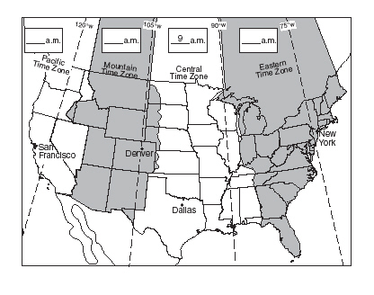

Solving Time Zone Problems: “The Grid Method”

Example 1: The time at 90ºE longitude is 7am. What is the time at 30ºE longitude?

Example 2: The time at 45ºW longitude is 2pm. At which longitude would the time be 7pm?

Date ____________
Time Zone Questions

1. Which lines, latitude or longitude, separate time zones? _____________

2. How many degrees are there in a standard time zone? _____________

3. If two ships in the Pacific Ocean are three hours ________________________
apart, how many degrees longitude separate them?

4. If two cities on the Earth have a 60˚ difference in ________________________
longitude, what is the time difference between the
two cities?

5. A person knows the solar time on the Prime Meridian and the local time. What determination can be made?
(1) the date (3) the longitude at which the person is located
(2) the altitude of Polaris (4) the latitude at which the person is located

6. Two cities on the globe have a 2 hour time difference.
What is the difference in longitude between the two cities?
- 15º (2) 30º (3) 45º (4) 60º

The diagram below shows the rotating Earth as it would
appear from a satellite over the North Pole.

7. The time at point X is closest to
(1) 6 am. .
(2) 12 noon
(3) 6 p.m
(4) 12 midnight

Use the Grid Method to answer questions 8-15. Show the grid below each question to support your answers.

8. How many hours of time exist between 45ºN, 15ºE and 60ºN, 60ºE? _____________

9. If the time at 75ºW longitude is 12:00pm, what time is it at 90ºW longitude? _____________

10. If the time at 120ºW longitude is 9:00pm, what time is it at 75ºW longitude? _____________

11. The time at the Prime Meridian is 5:00pm.
What would the time be at a location 45º east of the Prime Meridian? _____________

12. The time at 45ºW is 3:00am.
At which longitude would the time be 6:00am? _____________

13. The time in New York City (75ºW) is 11:00pm.
What would the time be at the Prime Meridian? _____________

14. If the time at 30ºE longitude is 1:00pm, what time is it at 45ºW longitude? _____________

15. The time at the Prime Meridian is 5:00pm.
At which longitude would the time be 9:00pm? _____________

Date ____________



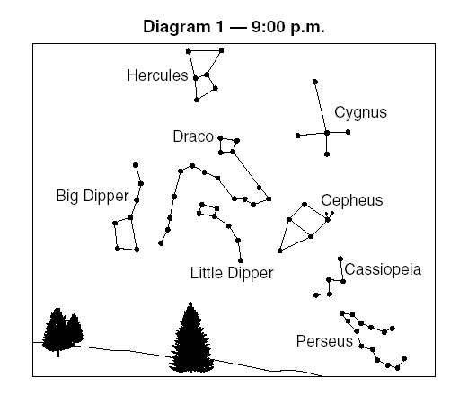

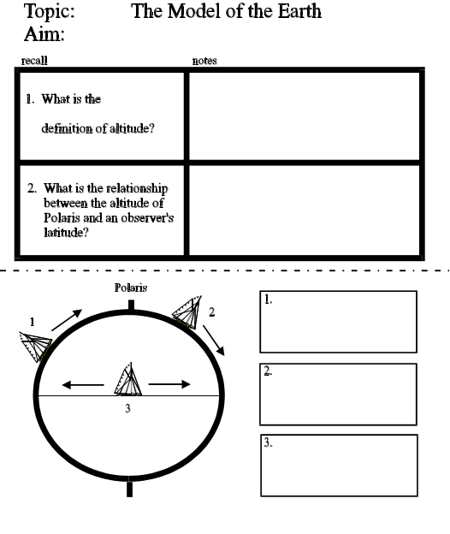
Date ____________
1. What is the definition
of altitude?
2. What is the
numerical range of
altitudes?
3. How does the altitude of
Polaris help determine an
observer’s latitude?
1

2

3
As a moving ship travels ___________________,

the observed altitude of Polaris will ___________________,
As a moving ship travels ___________________,

the observed altitude of Polaris will ___________________,
As a moving ship travels ___________________________.

the observed altitude of Polaris will ___________________,

Altitude - the height of an object above the
horizon measured in degrees.

- lowest = 0º – object on horizon

- highest = 90º – object is at observer’s
zenith (point directly above the observer)

The altitude of Polaris is equal to the latitude of the observer in the Northern Hemisphere.

Example:
If altitude of Polaris is 41º, the observer is standing on 41ºN latitude.

Latitude, Longitude, and the Altitude of Polaris,

- 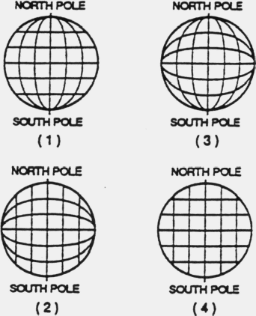The diagrams to the right represent four systems
of imaginary lines that could be used to locate
positions on a planet. Which system is most
similar to the latitude-longitude system used
on the Earth?

- The diagram below represents a portion of the Earth’s latitude and longitude system.
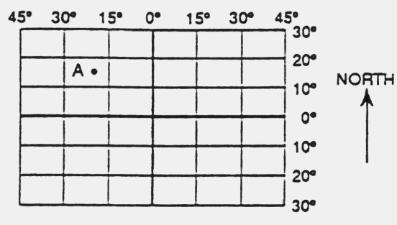

What are the approximate latitude and longitude of point A?
- 15ºS, 20ºW (3) 15ºN, 20ºW
- 15ºN, 20ºE (4) 15ºS, 20ºE

- According to the Earth Science Reference Tables, which city is located closest to 44º N latitude, 76º W longitude?
- Massena (3) Buffalo
- Binghamton (4) Watertown

- What is the location of Binghamton, New York?
- 42º 06‘ N, 75º 55’ W (3) 42º 54‘ N, 76º 05’ W
- 42º 06‘ N, 76º 05’ W (4) 42º 54‘ N, 75º 55’ W

- An observer on Earth measures the altitude of Polaris and finds it to be 90 degrees. The observer must be at the
- North Pole (3) Tropic of Cancer
(2) Arctic Circle (4) Equator

- On June 21, the altitude of Polaris is observed from New York City and is found to be 41º.
If the altitude is observed again on December 21, it will be
- 23 ½º (3) 49º
- 41º (4) 64 ½º

- 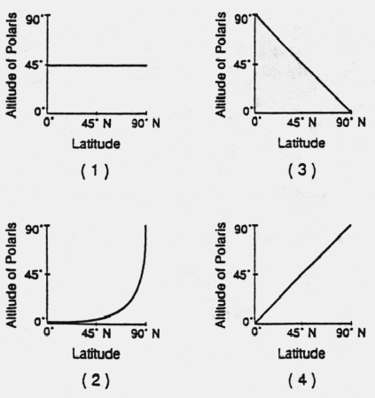Which graph best represents
the relationship between the
latitude of an observer and
the observed altitude of
Polaris above the northern
horizon?

- An observer on a moving ship notices that the altitude of Polaris decreases each night.
In what direction is the ship moving?
- due east (3) due west
- due south (4) due north

9. An observer on Earth measures the altitude of Polaris and finds it to be 0º. This observer must be at the
(1) North Pole (3) Tropic of Cancer
(2) Arctic Circle (4) Equator

10. As a ship crosses the Prime Meridian, the altitude of Polaris is 65º. What is the ship’s location?
- 0º latitude, 65º East longitude
- 0º latitude, 65º West longitude
- 65º North latitude, 0º longitude
- 65º South latitude, 0º longitude

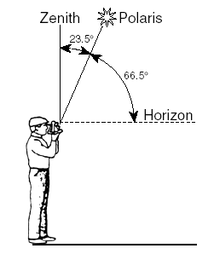
11. The diagram below shows an observer
on Earth measuring the altitude of Polaris.

What is the latitude of this observer?
(1) 90° N (3) 43° N
(2) 66.5° N (4) 23.5° N

12. What is the approximate altitude of Polaris at Syracuse, New York?
(1) 43° (3) 76°
(2) 47° (4) 90°

13. On the Generalized Bedrock Geology map of New York State what similar pattern
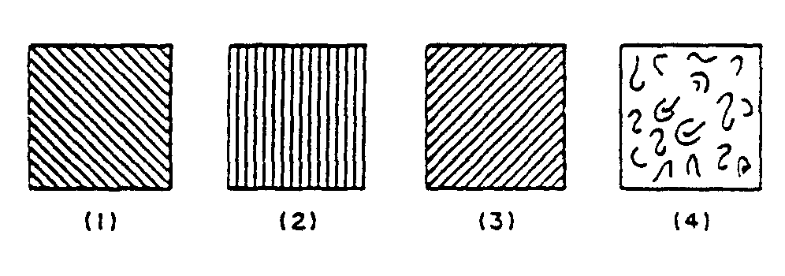
is found at 44° 30' north latitude by 74°30' west longitude?

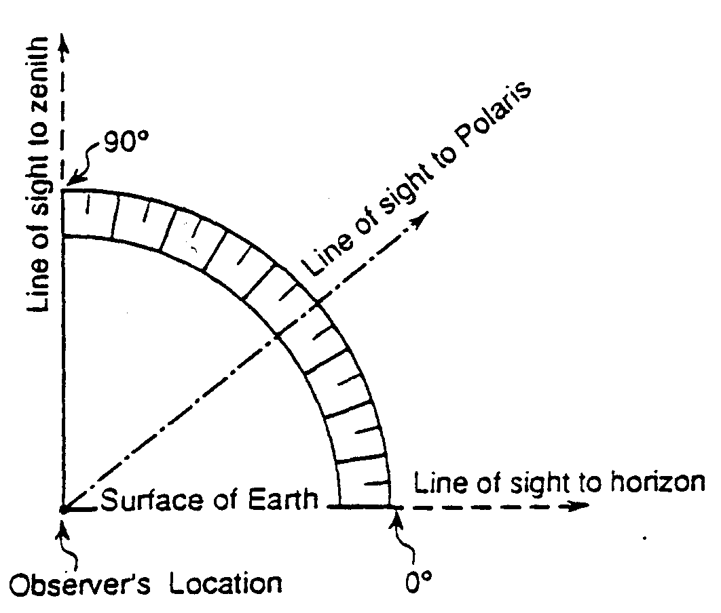
14. The diagram shows the altitude of Polaris above the horizon
at a certain location. What is the latitude of the observer?
(1) 10° N
(2) 40° N
(3) 50° N
(4) 90° N

Use the world map to answer questions 15-17.
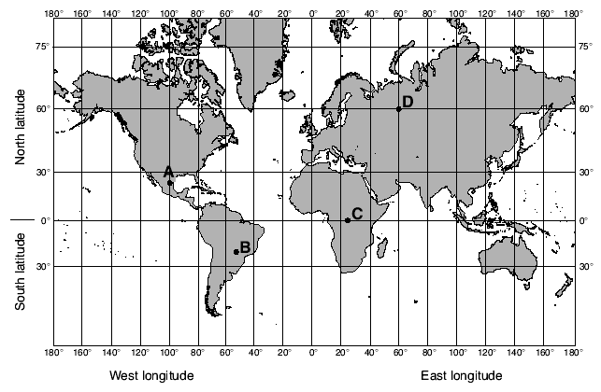

15. What is the latitude and longitude of point A? (don’t forget directions) __________________________

16. What is the latitude and longitude of point B? (don’t forget directions) __________________________

17. At which location could an observer not see Polaris in the night sky at any time during the year?
(1) A (3) C
(2) B (4) D

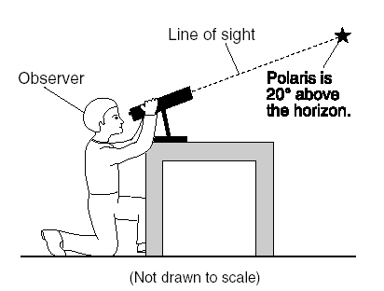
18. The diagram below shows an observer measuring the altitude
of Polaris. What is the latitude of the observer?
(1) 20° N (3) 70° N
(2) 20° S (4) 70° S

19. From which New York State location would Polaris be observed to have an altitude closest to
45° above the northern horizon?
(1) Massena (3) Watertown
(2) Utica (4) New York City

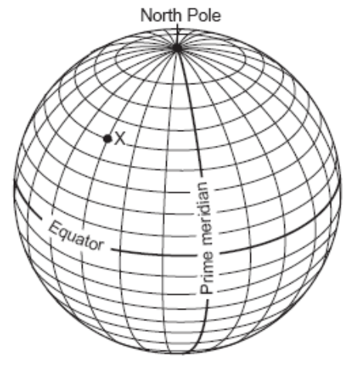
The diagram below shows latitude measurements
every 10 degrees and longitude measurements
every 15 degrees.

20. What is the latitude and longitude of point X?
(1) 40° S 45° E (3) 60° S 30° W
(2) 50° N 45° W (4) 75° N 30° E

Base your answers to questions 21 and 22 on the map below, which shows the latitude and longitude of five observers, A, B, C, D, and E, on Earth.

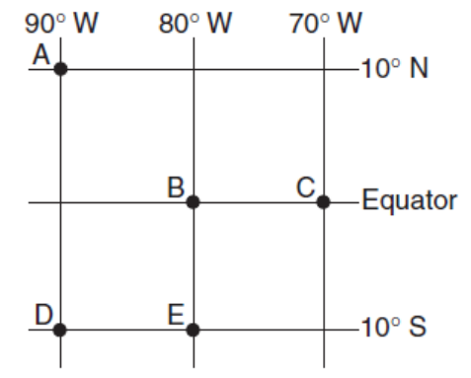
21. What are the coordinates of letter A?
(1) 0°, 90°W (3) 90°N, 10°W
(2) 10°N, 90°W (4) 10°W, 90°S

22. Which two observers would be able to observe Polaris
at the same altitude?
(1) A and C (3) B and E
(2) B and C (4) D and E

