Topic X
Part 2

Earthquakes

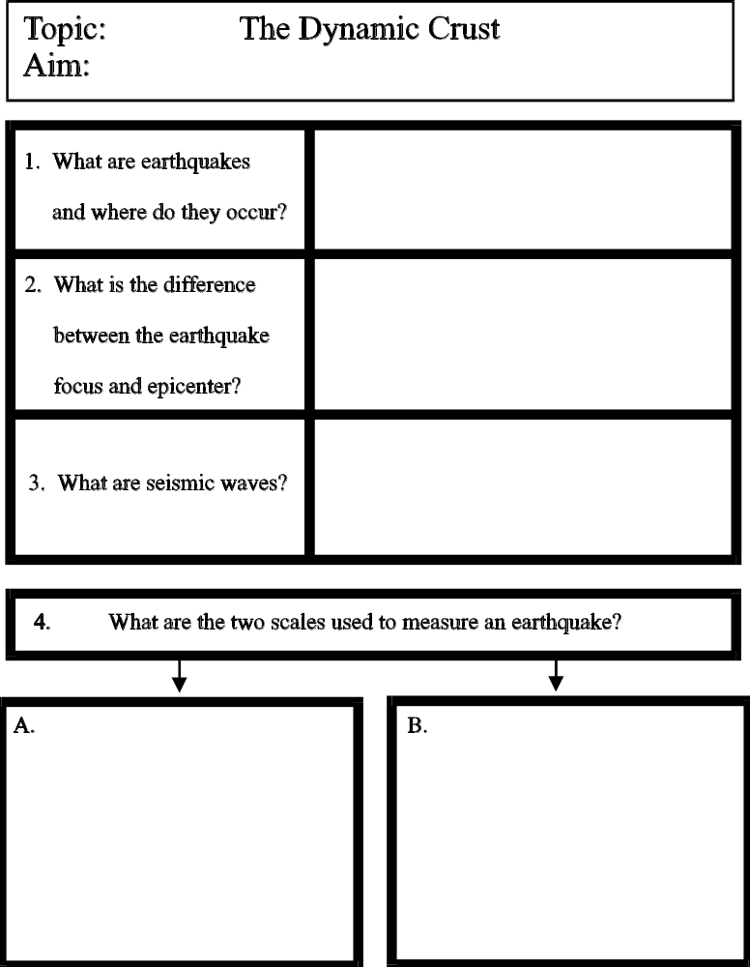
Earthquakes are the shaking, or rapid motion of the Earth’s crust.

Caused mainly by faulting
(a fracture/ break in the Earth’s crust along which there is motion).

FOCUS -

EPICENTER -

a large ocean wave created by an undersea earthquake

Modified Mercalli Scale
Measures intensity of earthquake based on observations and resulting damage.
I-XII

Note:
An earthquake might rate higher on the Mercalli Scale than on the Richter scale because damage can be greater in areas where cities are built on weak bedrock
even when the earthquake isn’t that strong.

Richter Scale
Measures magnitude of earthquake (energy released) using a seismograph.

1-10
(each successive number on scale is 10x stronger than the previous)

3. What is a tsunami?
4. What two scales are used to measure an earthquake?
2. What is the
difference between
an earthquake focus
and epicenter?

1. What are
earthquake and what
causes them?

Topic: Earthquakes
Aim:

Topic: Earthquakes
Aim:

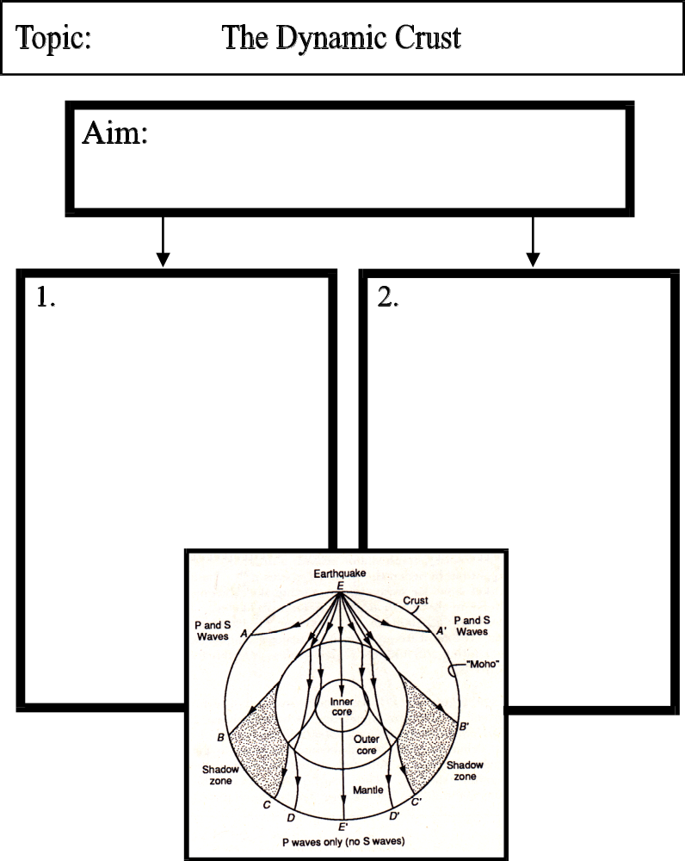
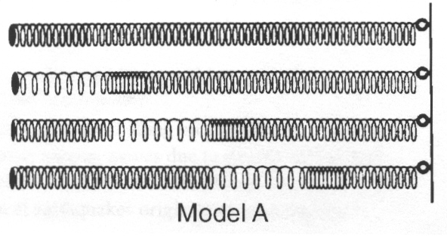
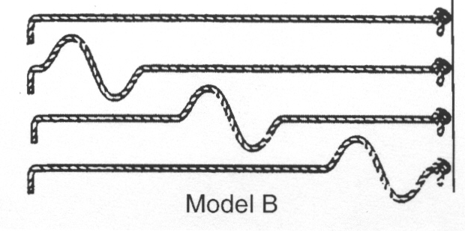
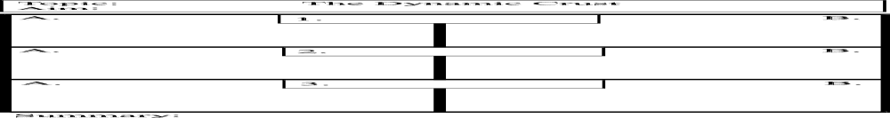

What are the properties of seismic waves?

Earthquakes

seismic waves - energy waves produced by an earthquake that travel through the Earth

If an earthquake occurs at point E, the waves of energy travel through the Earth. Notice that on the other side of the Earth only P-waves are detected because S-waves cannot travel through the liquid outer core
The waves of energy are bent (refracted) as they travel through substances of different densities.
Shadow zones are areas that no earthquake waves can be detected by seismographs because the P-waves are bent away from those areas and S-waves have already been absorbed by the liquid outer core.

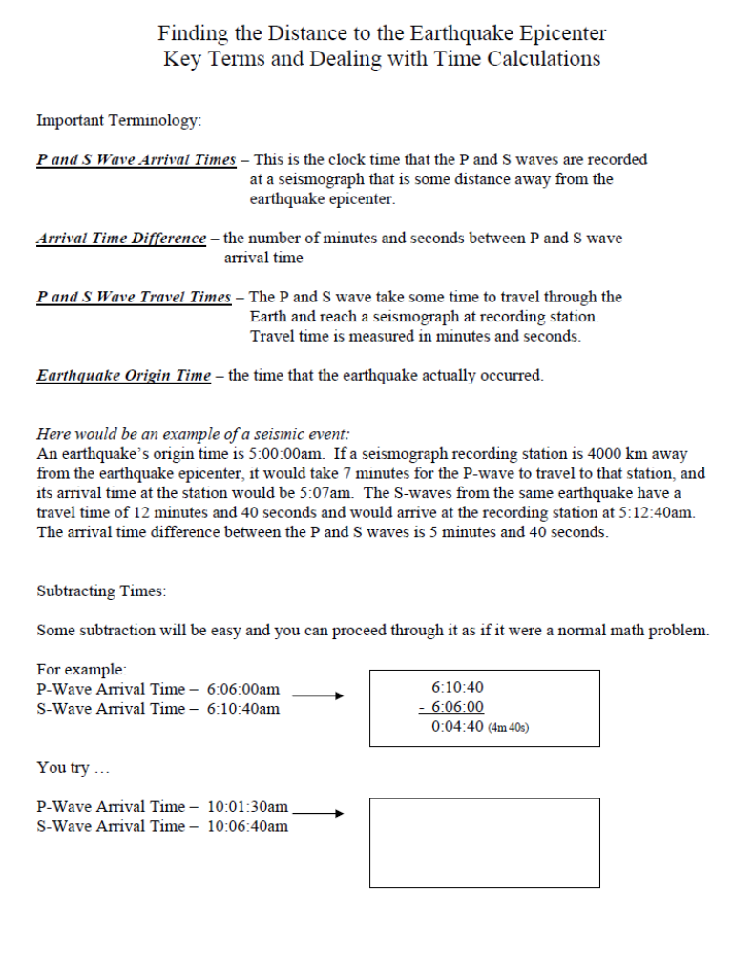

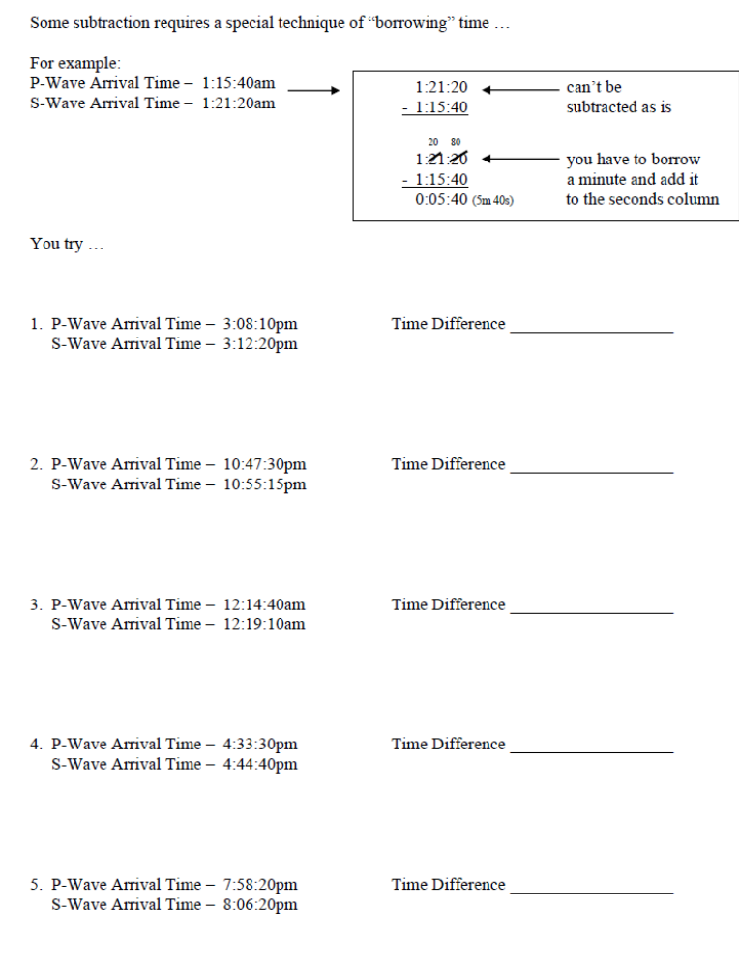
A SECOND EXAMPLE:

FOR EXAMPLE:
P-Wave Arrival Time – 11:30:20pm
S-Wave Arrival Time – 11:33:00pm

11:33:00
- 11:30:20

11:33:00
- 11:30:20
00:02:40

32 60
(2m 40s)
A SECOND EXAMPLE:
P-Wave Arrival Time – 1:15:40pm
S-Wave Arrival Time – 1:21:20pm

1:21:20
- 1:15:40

1:21:20
- 1:15:40
00:05:40

20 80

(5m 40s)

1.

2.

3.

4.

Finding the Distance to the Earthquake Epicenter

1. Find the difference in time between the
P-Wave and S-Wave Arrival Times.

Ex. P-wave arrival time = 5:40pm S-wave arrival time = 5:44pm
time difference (lag time) = 4 minutes

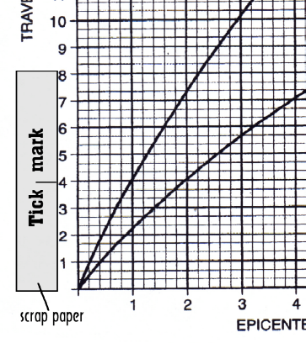2. Using a scrap of paper,
Mark off the
Arrival Time Difference
calculated in step #1
on the Y-Axis of the Grid.
(See Set-up to the right)

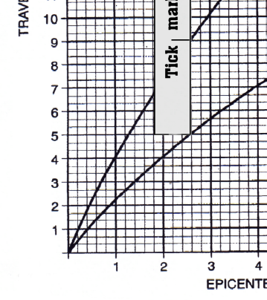
3. “Ride the P-Wave” –
Move the corner of
the scrap paper along
the P-Wave graph line
until the mark you made
hits the S-Wave graph line.

4. Go Straight down and
read off the
Distance to the Epicenter.

2.6 x 10³ km = 2600 km

Earthquake Data Interpretations

1. What is the distance to an earthquake epicenter if the P-wave ____________
arrival time is 2:31 p.m. and the S-wave arrival time is 2:37 p.m.?

2. If the earthquake detection station records the difference in arrival ____________
times between P-and S-waves is 10 minutes 20 seconds, what is the
distance to the earthquake epicenter from the recording station?

3. If the earthquake epicenter is 9000 km away from a recording ____________
station, how long is the P-wave travel time to that station?

4. If it takes 19 minutes and 40 seconds for the S-waves of an ____________
earthquake to reach a recording station, how far away is the
earthquake epicenter from that station?

5. If a seismograph station is 6600 km from an epicenter, and the ____________
P-wave arrived at this station at 7:30 a.m., what was the
origin time of the earthquake?

6. An earthquake struck a location at 1:35 p.m. If a seismograph station ____________
is 4000 km from the earthquake epicenter, at what time would the
first P-waves arrive at the seismograph station?

7. A seismic station is recording the seismic waves produced
by an earthquake that occurred 3000 kilometers away.
How long after the arrival of the first P-wave will the first S-wave arrive? ____________

8. An earthquake’s first P-wave arrives at a seismic station at 12:00:00.
This P-wave has traveled 6000 kilometers from the epicenter.
At what time will the first S-wave from the same earthquake arrive at the
seismic station? ____________

S
9. Use the seismogram below to fill in the chart that follows.

P

11:55am 12:00pm

a. P-Wave Arrival Time
b. S-Wave Arrival Time
c. Arrival Time Difference (Lag Time)
d. Distance to Epicenter
e. P-Wave Travel Time
f. S-Wave Travel Time
g. Earthquake Origin Time

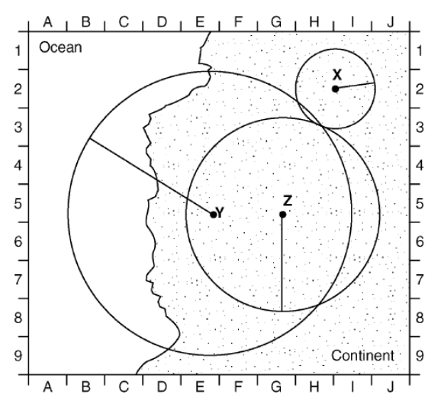
10. Base your answer to the following question on the diagram and
map below. The diagram shows three seismograms of the same
earthquake recorded at three different seismic stations, X, Y, and
Z. The distances from each seismic station to the earthquake
epicenter have been drawn on the map. A coordinate system has
been placed on the map to describe locations.

At which coordinate would the epicenter of this
earthquake be located?
- H-7
- H-3
- E-5
- G-5

PROBLEMS HANDLING SEISMIC WAVES: TAKE 2

Part of solving seismic wave related questions is figuring out the correct method to approach the problem.
BE SYSTEMATIC! Some questions can be done in one step, some require multiple steps.

THE FIRST THING YOU SHOULD ALWAYS DO:
Always begin a question by asking yourself what type of question you are dealing with ... Is it:
1. RIDE THE WAVE
2. JUST GO
3. X → : ORIGIN TIME
4. S AFTER P: REVERSE RIDE
Example 1:

Following an earthquake, a seismograph station recorded
the arrival of a P-wave at 1:05:00 a.m. and an S-wave at
1:14:30 a.m. What is the distance from the seismograph
station to the epicenter of the earthquake? _______________________

Example 2:

How far does an earthquake P-wave travel in 3 minutes 40 seconds? _______________________

Example 3:
The distance from a seismic recording station to an earthquake
epicenter is 1800km. The station recorded the arrival of the first
P-waves from the earthquake at 5:06pm. What time would the
first S-waves arrive at the recording station? _______________________

Example 4:
A seismographic station determines that its distance from
the epicenter of an earthquake is 3000 kilometers. If the
P-wave arrived at the station at 9:10:00 a.m., the time of the
earthquake's origin was _______________________

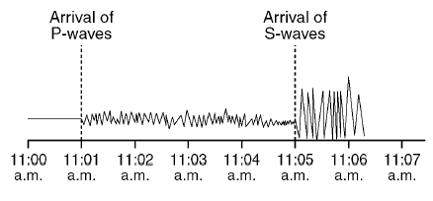
Example 5:

According to the data in the
|seismogram, what is the
distance to the epicenter?
_______________________

Some Final Practice Questions on Earthquakes

1. How long would it take for the first S-wave to arrive at a seismic station 3,000 kilometers away from the
epicenter of an earthquake?
(1) 4 min 20 sec (3) 10 min 10 sec
(2) 5 min 40 sec (4) 13 min 20 sec

Base your answers to questions 2 and 3 on the cross-sectional view of Earth below, which shows seismic
waves traveling from the focus of an earthquake. Points A and B are locations on Earth’s surface.
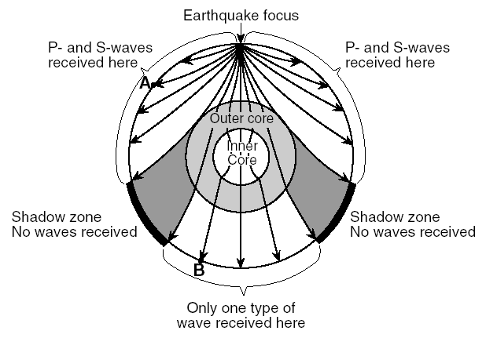
2. Which statement best explains why only one type of seismic
wave was recorded at location B?
(1) S-waves cannot travel through the liquid outer core.
(2) S-waves cannot travel through the liquid inner core.
(3) P-waves cannot travel through the solid outer core.
(4) P-waves cannot travel through the solid inner core.

3. A seismic station located at point A is 5400 kilometers away from the epicenter of the earthquake. If the
arrival time for the P-wave at point A was 2:00 p.m., the arrival time for the S-wave at point A was
approximately
(1) 1:53 p.m. (3) 2:09 p.m.
(2) 2:07 p.m. (4) 2:16 p.m.

4. Which seismogram was recorded approximately 4,000 kilometers from an earthquake epicenter?
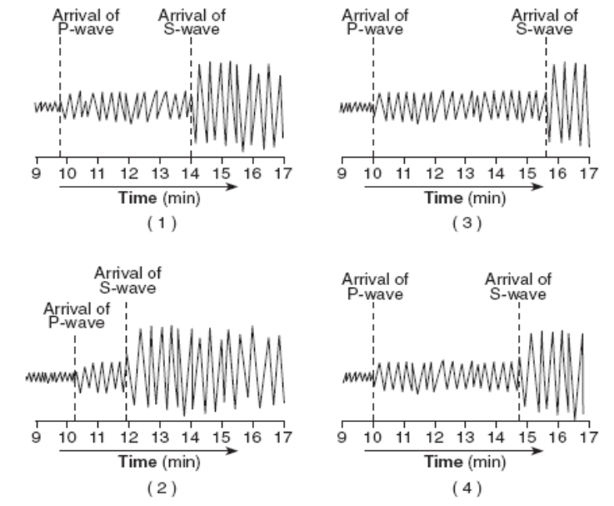

Questions 5-6: The diagram below represents three seismograms showing the same earthquake
as it was recorded at three different seismic stations, A, B, and C.
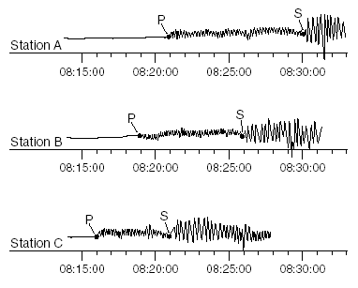

5. Which statement correctly describes the distance between the earthquake epicenter and these seismic stations?
(1) A is closest to the epicenter, and C is farthest from the epicenter.
(2) B is closest to the epicenter, and C is farthest from the epicenter.
(3) C is closest to the epicenter, and A is farthest from the epicenter.
(4) A is closest to the epicenter, and B is farthest from the epicenter.

6. What is the distance to the epicenter from station C?
(1) 1300 km (3) 3400 km
(2) 2600 km (4) 4000 km

7. The distance from Albany, New York, to the epicenter of this earthquake is 5600 km. Approximately how much
longer did it take for the S-wave to arrive at Albany than the P-wave?
(1) 4 minutes and 20 seconds (3) 9 minutes and 0 seconds
(2) 7 minutes and 10 seconds (4) 16 minutes and 10 seconds

8. If a P-wave takes 8 minutes and 20 seconds to travel from an earthquake epicenter to a seismic recording station,
how far away from that station did that earthquake occur?
(1) 4000 km (3) 6000 km
(2) 5000 km (4) 8000 km

