Topic X
Part 1

Plate
Tectonics

Topic : Plate Tectonics
Aim:

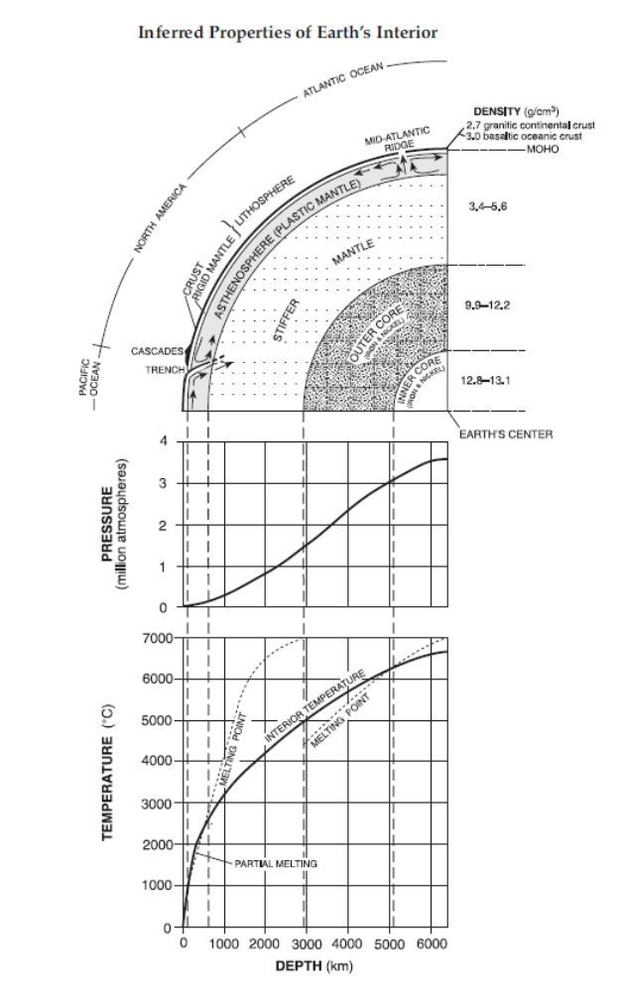
Knowledge of Earth’s interior is based on

___________________

___________________

___________________

When Earth formed, it separated into layers based on

____________________
2a. continental crust

2b. oceanic crust

3. Moho -

4. Asthenosphere -

6.

5. Outer Core -

7.

Since the actual temperature is higher than the melting point of the material in these layers, the material melts fully or partially and has the properties of a liquid.

Earth’s Interior

1. The oceanic crust is composed mainly of
(1) dense basalts (3) low density granites
(2) clastic sandstones (4) metamorphic gneiss
2. Earth’s inner core is inferred to be solid based on the analysis of
(1) seismic waves (3) radioactive decay rates
(2) crustal rocks (4) magnetic pole reversals
3. Which combination of temperature and pressure is inferred to occur within Earth’s stiffer mantle?
(1) 3500°C and 0.4 million atmospheres
(2) 3500°C and 2.0 million atmospheres
(3) 5500°C and 0.4 million atmospheres
(4) 5500°C and 2.0 million atmospheres
4. Which part of Earth’s interior is inferred to have convection currents that cause tectonic plates to move?
(1) rigid mantle (3) outer core
(2) asthenosphere (4) inner core
5. What caused the interior of Earth to separate into layers?
(1) a decrease in the rate of rotation of Earth
(2) the gravitational pull on materials of varying densities
(3) variations in heating by the Sun due to Earth’s tilt
(4) collisions with meteors and comets

6. Which layer of the Earth’s interior exists at a depth of 5000 km?
1 stiffer mantle 3 inner core
2 asthenosphere 4 outer core

7. The diagram below represents a location near the edge of a continent.
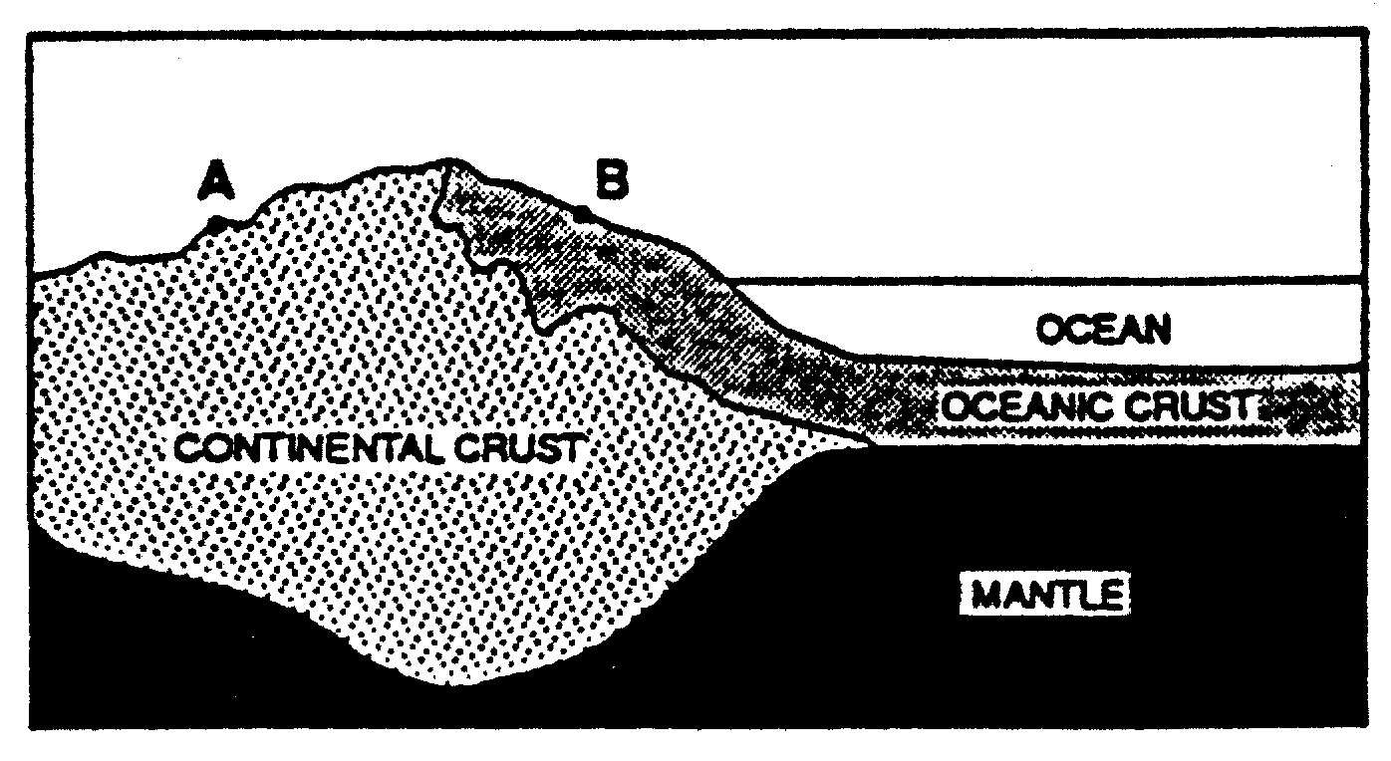

A geologist who compares non-sedimentary rock samples from locations A and B would
probably find that samples from location A contain
- more granite 3 more fossils
- more basalt 4 the same minerals and fossils

8. Which layer of Earth’s interior is in the liquid state?
- inner core 3 crust
- outer core 4 mantle

9. According to the Earth Science Reference Tables, in which region of the Earth’s interior would
material with a density of 10 grams per cubic centimeter most likely be found?
- inner core 3 crust
- outer core 4 mantle

10. The temperature of a rock located 1,000 kilometers below the Earth’s surface is about
1 200 ºC 3 2800 ºC
2 2100 ºC 4 3200 ºC

11. Which statement correctly describes the density of Earth’s mantle compared to the density of
Earth’s core and crust?
(1) The mantle is less dense than the core but more dense than the crust.
(2) The mantle is less dense than both the core and the crust.
(3) The mantle is more dense than the core but less dense than the crust.
(4) The mantle is more dense than both the core and the crust.

12. In which layer of Earth’s interior is the thinnest?
(1) outer core (3) crust
(2) inner core (4) stiffer mantle

13. How does the oceanic crust compare to the continental crust?
1 The oceanic crust is thinner and contains less basalt.
2 The oceanic crust is thinner and contains more basalt.
3 The oceanic crust is thicker and contains less basalt.
4 The oceanic crust is thicker and contains more basalt.

14. As depth increases, the temperature within the Earth
1 increases, but the pressure decreases
2 decreases, but the pressure increases
3 increases, and the pressure also increases
4 decreases, and the pressure also decreases

15. The lithosphere consists of
1 the oceanic crust only
2 the continental crust only
3 the crust and the rigid mantle
4 the rigid mantle and asthenosphere

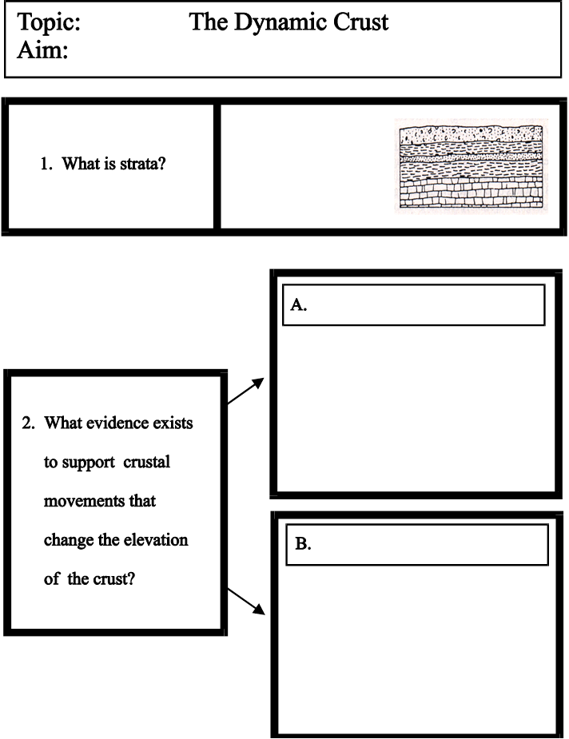
Topic : Plate Tectonics
Aim:

horizontal layers of sedimentary rock

indicates that crustal has not been disturbed

- What is strata?

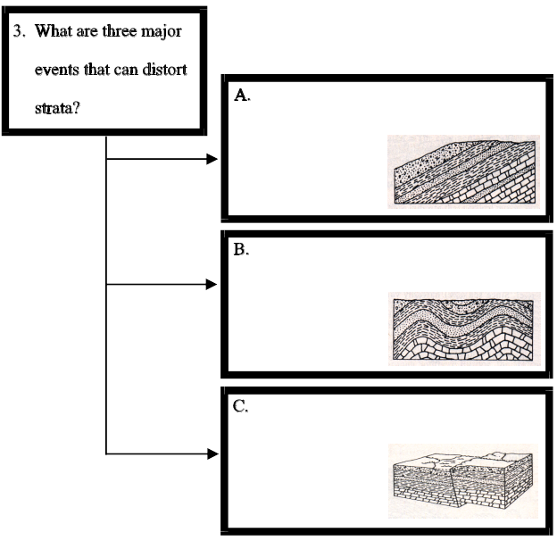

2. What events
show evidence of
crustal movement?
a.
b.
c.

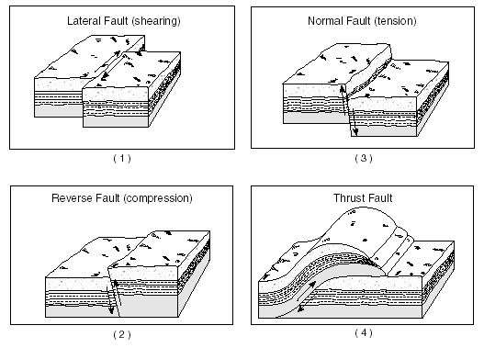

d.

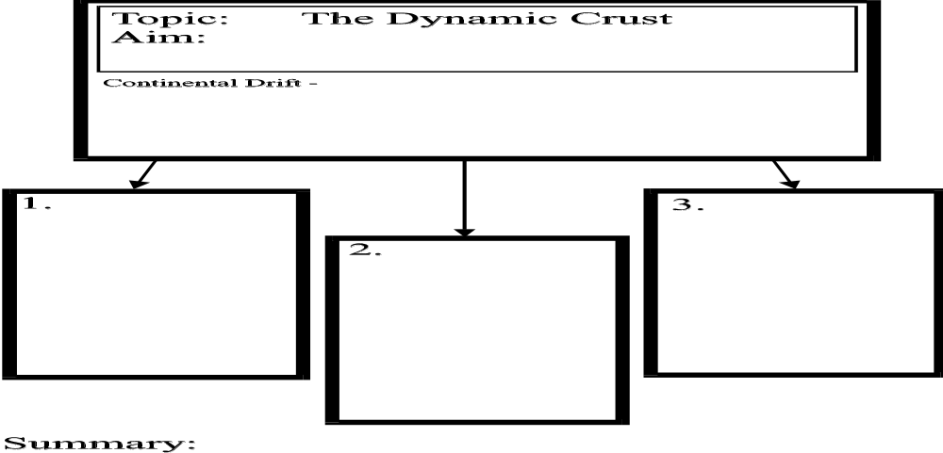
Topic : Plate Tectonics
Aim:

Alfred Wegener – 1912

a theory which proposed that the continents have moved
apart over millions of years of slow movement

1. 2. 3.

Divergent Plate Boundary
plates move away from each other

Mid Ocean Ridges
submerged mountain and volcanic ranges

convection currents
in mantle drive plate movements
- causes hot material to rise up to create new oceanic crust
(youngest rocks are found nearest to ridge)
Convergent Plate Boundary
continent-to-continent collision

- lithosphere piles up
thickening the crust

- leads to mountain
building

Ex. formation of the
Himalayas in India

Convergent Plate Boundary
ocean crust-to-continent collision

Subduction Zones
- dense ocean crust
forced under continent
- ocean crust sinks into
mantle and melts

- forms volcanoes and
volcanic island arcs

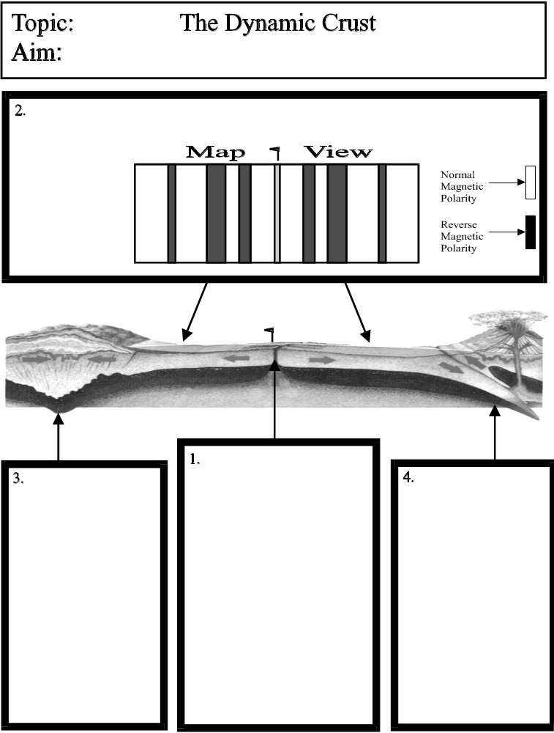
Divergent Plate Boundary
plates move away from each other

Mid Ocean Ridges
submerged mountain and volcanic ranges

convection currents
in mantle drive plate movements
- causes hot material to rise up to create new oceanic crust
(youngest rocks are found nearest to ridge)

Convergent Plate Boundary
continent-to-continent collision

- lithosphere piles up
thickening the crust

- leads to mountain
building

Ex. formation of the
Himalayas in India

Convergent Plate Boundary
ocean crust-to-continent collision

Subduction Zones
- dense ocean crust
forced under continent
- ocean crust sinks into
mantle and melts

- forms volcanoes and
volcanic island arcs

Magnetic Reversals provide evidence for sea-floor spreading
- symmetrical pattern on opposite sides of ridge - cyclical shifting of Earth’s magnetic pole

Topic : Plate Tectonics
Aim:

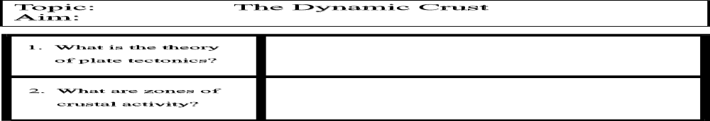
Topic : Plate Tectonics
Aim:

1. What is the
theory of
plate tectonics?
Plate Tectonics = Continental Drift + Sea-Floor Spreading
“PANGAEA” (supercontinent when all continents were attached)
broke up as a result of “floating” plates moving because of
convection currents in the asthenosphere.

a.
b.

c.

d.
2. What events
occur at or near
zones of
crustal activity?

3. What occurs
at mantle
hot spots?

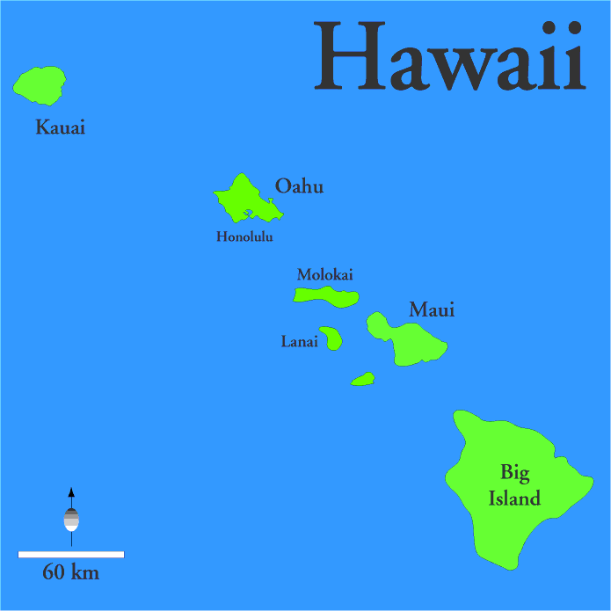

Hot spots are places in the Earth’s surface that magma rises up from the mantle.

Example – the Hawaiian Islands

As the crust moves over a hot spot, a chain of volcanic mountains form.
If the mountains build up enough, they
rise above sea level to make islands.
The active volcano in the chain is the one directly over the hot spot.

Plate Tectonics Review

1. The basaltic bedrock of the oceanic crust is classified as
(1) felsic, with a density of 2.7 g/cm³ (3) felsic, with a density of 3.0 g/cm³
(2) mafic, with a density of 2.7 g/cm³ (4) mafic, with a density of 3.0 g/cm³

2. At which plate boundary is one lithospheric plate sliding under another?
(1) Nazca Plate and Antarctic Plate
(2) Pacific Plate and Indian-Australian Plate
(3) Indian-Australian Plate and Antarctic Plate
(4) Nazca Plate and Pacific Plate

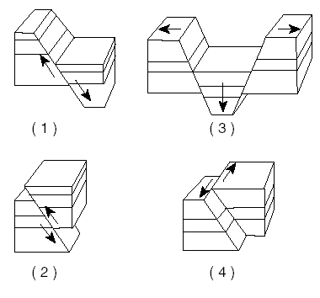
3. Which block diagram best shows a transform fault?

4. Alternating parallel bands of normal and reversed magnetic polarity are found in the basaltic
bedrock on either side of the
(1) Mid-Atlantic Ridge (3) San Andreas Fault
(2) Yellowstone Hot Spot (4) Peru-Chile Trench

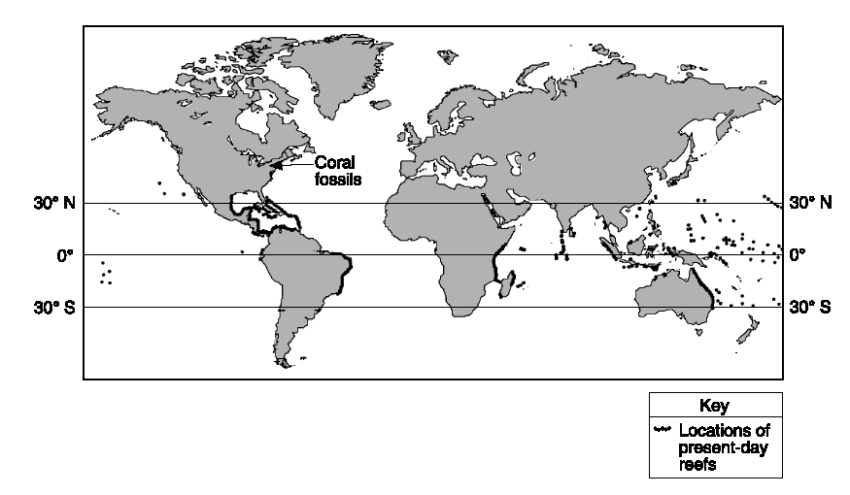
5. On the map , the darkened
areas represent locations where
living corals currently exist. The
arrow points to a location where
coral fossils have been found in
Devonian-age bedrock in
New York State.

Devonian-age coral fossils found in some New York State bedrock are not located in
the same general region that present-day corals are living because during the Devonian Period
(1) corals migrated to New York State (3) New York State was closer to the equator
(2) corals lived everywhere on Earth (4) New York State had a colder climate

6 According to the Earth Science Reference Tables, which of the following locations is the site of a
convergent plate boundary?
(1) the mid-Atlantic ridge (3) the Atlantic-Indian ridge
(2) the Aleutian trench (4) the Pacific/North American plate boundary

7. The edges of most lithospheric plates are characterized by
(1) reversed magnetic orientation (3) unusually rapid radioactive decay
(2) frequent earthquake and volcanic activity (4) low P-wave and high S-wave velocity

8. Which temperature is inferred to exist in Earth’s plastic mantle?
(1) 2000°C (3) 5000°C
(2) 3000°C (4) 6000°C

9. Convection currents in the plastic mantle are believed to cause divergence of lithospheric plates at the
(1) Peru-Chile Trench (3) Canary Islands Hot Spot
(2) Mariana Trench (4) Iceland Hot Spot

10. The movement of tectonic plates is inferred by many scientists to be driven by
(1) tidal motions in the hydrosphere (3) density differences in the troposphere
(2) solidification in the lithosphere (4) convection currents in the asthenosphere

11. Why does the oceanic crust sink beneath the continental crust at a subduction boundary?
(1) The oceanic crust has a greater density.
(2) The oceanic crust is pulled downward by Earth’s magnetic field.
(3) The continental crust has a more mafic composition.
(4) The continental crust is pulled upward by the Moon’s gravity.

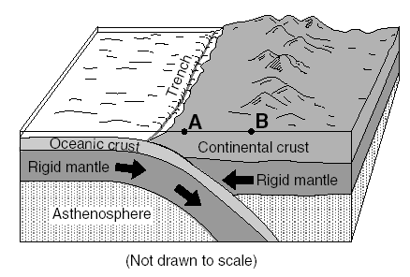
12. The block diagram below shows a tectonic plate boundary. Points A and B represent locations on
Earth’s surface.

The diagram represents
- subduction at a divergent plate boundary
- subduction at a convergent plate boundary
- rifting at a convergent plate boundary
- rifting at a transform plate boundary

13. Which statement correctly describes the density of Earth’s mantle compared to the density of Earth’s
core and crust?
(1) The mantle is less dense than the core but more dense than the crust.
(2) The mantle is less dense than both the core and the crust.
(3) The mantle is more dense than the core but less dense than the crust.
(4) The mantle is more dense than both the core and the crust.

14. According to tectonic plate maps, New York State is presently located
(1) at a convergent plate boundary (3) above a mid-ocean ridge
(2) above a mantle hot spot (4) near the center of a large plate

Base your answers to questions 15 through 17 on the map of the Mid-Atlantic Ridge shown below.
Points A through D are locations on the ocean floor. Line XY connects locations in North America and Africa.
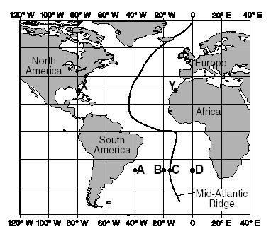

15. In which cross section do the arrows best show the convection
occurring within the asthenosphere beneath line XY?
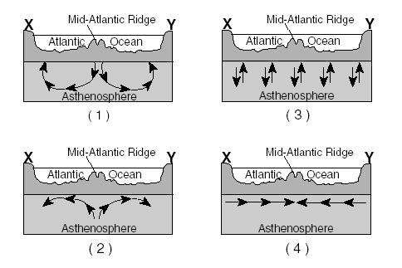

16. Samples of ocean-floor bedrock were collected at points A, B, C, and D.
Which sequence shows the correct order of the age of the bedrock from oldest to youngest?
(1) D → C → B → A (3) C → B → D → A
(2) A → D → B → C (4) A → B → D → C

17. The boundary between which two tectonic plates is most similar geologically to the plate boundary at the
Mid-Atlantic Ridge?
(1) Eurasian and Indian-Australian (3) Pacific and Nazca
(2) Cocos and Caribbean (4) Nazca and South American

18. What is the inferred temperature at the boundary between Earth’s stiffer mantle and outer core?
(1) 2,500°C (3) 5,000°C
(2) 4,500°C (4) 6,200°C

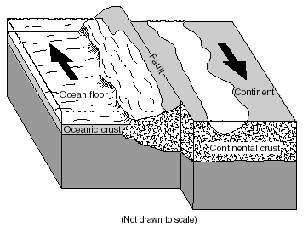
19. Arrows in the block diagram below show the relative movement along a tectonic plate boundary.

Between which two tectonic plates does this type of plate boundary exist?
(1) Nazca Plate and South American Plate
(2) Eurasian Plate and Indian-Australian Plate
(3) North American Plate and Eurasian Plate
(4) Pacific Plate and North American Plate

20. How does the oceanic crust compare to the continental crust?
(1) The oceanic crust is thinner and contains less basalt.
(2) The oceanic crust is thinner and contains more basalt.
(3) The oceanic crust is thicker and contains less basalt.
(4) The oceanic crust is thicker and contains more basalt.

21. Which is the best evidence supporting the concept of ocean floor spreading?
(1) Earthquakes occur at greater depths beneath continents than beneath oceans.
(2) Sandstones and limestones can be found both in North America and Europe.
(3) Volcanoes appear at random within the oceanic crust.
(4) Igneous rocks along the mid-ocean ridges are younger than those farther from the ridges.

22. Scientists have inferred the structure of Earth’s interior mainly by analyzing
(1) the Moon’s interior (3) Earth’s surface features
(2) the Moon’s composition (4) Earth’s seismic data

23. What happens to the density and temperature of rock within Earth’s interior as depth increases?
(1) density decreases and temperature decreases
(2) density decreases and temperature increases
(3) density increases and temperature increases
(4) density increases and temperature decreases

24. The diagram to the right represents a cross section of a portion of the Earth’s crust.
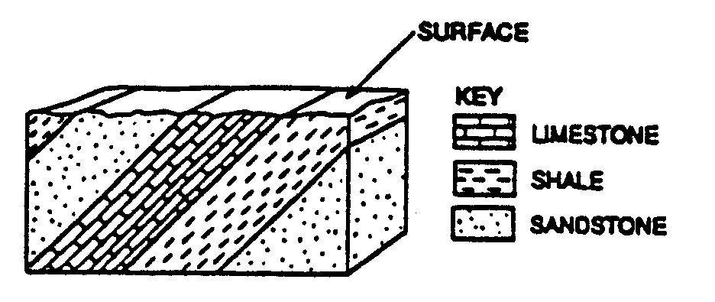

What do these tilted rock layers suggest?
- This area has remained fairly stable since the sediments were deposited.
- The sediments were deposited at steep angles and then became rock.
- Metamorphism followed the deposition of the sediments.
- Crustal movement occurred sometime after the rocks were deposited.

25. Which diagram best represents the polarity of the magnetic field preserved in the ocean-floor bedrock found
on both sides of the Mid-Indian Ridge?



